# Financial Policy Summary

The Financial Policy Committee (FPC) seeks to ensure the UK financial system is prepared for, and resilient to, the wide range of risks it could face – so that the system is able to absorb rather than amplify shocks and serve UK households and businesses.

### The overall risk environment

##### The overall risk environment remains broadly unchanged from Q1. Markets continue to price mostly for a benign central case outlook, and some risk premia have tightened

**even further, despite the global risk environment facing several challenges. Some of these challenges have become more concerning and proximate.**

In aggregate, UK household and corporate borrowers have been resilient, although many remain under pressure. UK banks are in a strong position to support households and businesses, even if economic and financial conditions were substantially worse than expected.

The adjustment to the higher interest rate environment is continuing globally, including as businesses and households refinance their debt. Risks are crystalising in the US commercial real estate market and important vulnerabilities in market-based finance are yet to be addressed globally.

### Developments in ﬁnancial markets

**The Monetary Policy Committee’s (MPC’s) central projection for UK GDP growth, unemployment and inflation has improved slightly further since Q1, and global growth is projected to rise in the medium term, although several risks to that outlook remain.** Economic data news has pushed out market expectations on the timing of reductions in policy rates in the US and UK, although rate cuts have now begun in some jurisdictions. Markets responded to the announcement that French parliamentary elections would be held on 30 June and 7 July. For example, the spread between French and German 10-year government bond yields rose to its highest level since 2017.

**Risk premia on US equities have been compressed for some time but have also fallen across a range of other markets this year and are now very low by historic standards, including for more leveraged borrowers.** While there is some evidence of investors demanding higher risk premia on small pockets of the riskiest bonds, the widespread overall compression of risk premia, in an uncertain risk environment, suggests that investors are continuing to put less weight on risks to the macroeconomic outlook. Valuations and risk

premia are therefore vulnerable to a shift in risk appetite that could be triggered by factors including a weakening of growth prospects, more persistent inflation, or a further deterioration in geopolitical conditions.

##### Although financial market asset valuations have so far been robust to large increases in interest rates and recent geopolitical events, the adjustment to the higher interest rate environment is not yet complete and market prices remain vulnerable to a sharp

**correction**. This could adversely affect the cost and availability of finance to the real economy via two main channels. First, a sharp market correction would make it more costly and difficult for corporates to refinance maturing debt, including by reducing the value of collateral. This is particularly relevant given the large proportion of leveraged lending and high-yield market- based corporate debt that is due to mature by the end of 2025. Second, it could interact with vulnerabilities in market-based finance, which may amplify the correction. For example, it may cause large losses for leveraged market participants, which could further reduce risk appetite, or it may lead to a spike in liquidity demand and a deterioration in the functioning of core markets.

### Global vulnerabilities

**Global vulnerabilities remain material.** US commercial real estate (CRE) borrowers have significant short-term refinancing needs and a number of overseas banks with large exposures to CRE, in the US and other jurisdictions, experienced significant falls in their equity prices earlier in the year. Stresses in global CRE markets could affect UK financial stability through several channels, including a reduction in overseas finance for the UK CRE sector.

**Policy uncertainty associated with upcoming elections globally has increased.** This could make the global economic outlook less certain and lead to financial market volatility. It could also increase existing sovereign debt pressures, geopolitical risks, and risks associated with global fragmentation, all of which are relevant to UK financial stability.

### UK household and corporate debt vulnerabilities

**In the context of strong nominal household income growth and continued low unemployment, the aggregate UK household debt to income ratio has continued to fall. That said, many UK households, including renters, remain under pressure from higher living costs and higher interest rates.** The share of households spending a high proportion of their available income servicing their mortgages is expected to increase slightly over the next two years, but it is likely to remain well below pre-global financial crisis (GFC) levels.

Mortgage arrears remain low by historical standards and are expected to remain well below their previous peaks.

##### Aggregate measures of UK corporate debt vulnerability have fallen further and corporates are likely to remain broadly resilient to the current economic outlook,

**including high interest rates. But there remain pockets of vulnerability among highly leveraged corporates.** Despite strong issuance so far in 2024, a significant portion of market-based corporate debt is due to mature in the coming years, so risks associated with the need to refinance at higher interest rates remain. The most highly leveraged and lowest rated corporates, including those backed by private equity, are likely to be more exposed to this risk.

### Private equity

**The private equity (PE) sector grew rapidly during the period of low interest rates and plays a significant role in financing UK businesses.** The long-term nature of capital investments into PE allows and incentivises fund managers to act less cyclically, which can reduce the volatility of financing flows in macroeconomic downturns. **However, the**

##### widespread use of leverage within PE firms and their portfolio companies makes them particularly exposed to tighter financing conditions.

**Although the sector has been resilient so far, it is facing challenges in the higher rate environment. These manifest in refinancing risk as debt matures, and an increased**

**drag on performance from higher financing costs**. Vulnerabilities from high leverage, opacity around valuations, and strong interconnections with riskier credit markets mean the sector has the potential to generate losses for banks and institutional investors, and cause market spillovers to highly correlated and interconnected markets such as leveraged loans and private credit – all of which could reduce investor confidence, further tightening financing conditions for businesses. Disruptions in international PE markets could also spill over to the UK, particularly from US markets given their size and importance, and because the majority of PE funds backing UK corporates are based in the US.

##### Improved transparency over valuation practices and overall levels of leverage would help to reduce the vulnerabilities in the sector. Risk management practices in some parts of the sector also need to improve, including among lenders to the sector such as banks. The FPC will consider the outcome of regulatory work by the Financial Conduct Authority and Prudential Regulation Authority to address some of these issues. Because of the interconnections between PE markets in different jurisdictions,

international co-ordination will be important.

### UK banking sector resilience

**The UK banking system has the capacity to support households and businesses, even if economic and financial conditions were to be substantially worse than expected.** The UK banking system is well capitalised and UK banks maintain strong liquidity positions. The

return on equity of major UK banks in aggregate has risen to around their cost of equity, and asset quality remains strong.

**The FPC judges that changes in credit conditions overall reflect changes to the macroeconomic outlook.** Mortgage approvals have risen, in part in response to a fall in quoted mortgage rates since last summer. Overall credit conditions for corporates have remained broadly unchanged since the start of the year.

**A number of system-wide factors are likely to affect bank funding and liquidity in the coming years, including as central banks normalise their balance sheets as the extraordinary measures put in place following the GFC and the Covid pandemic are unwound.** The Bank of England is unwinding its holdings in its Asset Purchase Facility, as

determined by the MPC, and the Term Funding Scheme with additional incentives for SMEs is coming to an end. **It is important that banks factor these system-wide trends into their liquidity management and forward planning over the coming years.** Banks have a number of ways in which they can manage their funding and liquidity, including use of the Bank of England’s facilities, such as the Short-Term Repo and Indexed Long-Term Repo facilities.

### The UK countercyclical capital buffer rate decision

**The FPC is maintaining the UK countercyclical capital buffer (CcyB) rate at its neutral setting of 2%.** The FPC will continue to monitor developments closely and stands ready to vary the UK CcyB rate, in either direction, in line with the evolution of economic and financial

conditions, underlying vulnerabilities, and the overall risk environment. The Bank’s 2024 desk- based stress test will further inform the FPC’s assessment of the resilience of the UK banking system to downside risks.

### The resilience of market-based ﬁnance

**There remain important vulnerabilities in market-based finance that the FPC has previously identified. In particular, leveraged positions, which have been a driver of a number of recent stress events, appear to be increasing among hedge funds.** The work of international and domestic regulators to develop appropriate policy responses to address the risks of excessive leverage is therefore important. **The FPC supports the Financial Stability Board’s international work programme on leverage in non-bank financial institutions, and encourages authorities globally to take action to reduce the vulnerabilities through internationally co-ordinated policy reforms.**

##### Given the significant progress made on liability-driven investment (LDI) fund resilience across domestic and international authorities over the past 18 months, the FPC has

**closed its November 2022 and March 2023 Recommendations on LDI resilience.** Its

March 2023 Recommendation that The Pensions Regulator should have the remit to take into account financial stability considerations in its work on a continuing basis remains in place.

**The FPC welcomes the launch of the second round of the Bank’s system-wide exploratory scenario (SWES) exercise.** In the first round, the hypothetical SWES scenario led most participating non-bank financial institutions to report significant liquidity needs from margin calls. Many participants started the scenario with greater resilience than they had at the onset of recent market shocks. For example, the current level of resilience of money market funds is well above existing minimum requirements. This is also in part the result of recent regulatory actions, such as the LDI resilience standard recommended by the FPC. Participants therefore expected those liquidity needs could be mostly met by pledging assets. However, participants’ responses also implied that terms in the sterling repo market would tighten, and that there would be selling pressure in the sterling corporate bond market.

In the second round, the Bank is exploring the assumptions underpinning participants’ actions and how different assumptions might alter actions taken and lead to different outcomes in markets. **The analysis has already provided important insights which demonstrate the value of system-wide exercises. The overall results of the exercise will be published in 2024 Q4.**

# 1: Developments in ﬁnancial markets

### Key developments since the December 2023 FSR

Economic data news has pushed out market expectations on the timing of reductions in policy rates in the US and UK, although cuts in some jurisdictions have started. Longer-term borrowing costs remain broadly unchanged.

Core government bond markets have functioned well since the December FSR, with interest rate volatility having fallen back towards historical averages.

Valuations across a range of asset classes are stretched with measures of risk premia materially more compressed since the December FSR.

The FPC judges that risk premia and asset valuations remain vulnerable to a shift in risk appetite. An adjustment could be triggered by factors including a weakening of growth prospects, more persistent inflation or a further deterioration in geopolitical conditions.

Should these downside risks materialise, a change in sentiment could lead to a sharp correction, adversely affecting the cost and availability of finance to the real economy in a number of ways, including by interacting with longstanding vulnerabilities in market-based finance (see Section 6).

##### Market participants continue to expect policy rates to remain high for an extended period.

Economic data news has pushed out market expectations on the timing of reductions in policy rates in the US and UK, although rate cuts have now begun in some jurisdictions.

Markets continue to anticipate that policy rates will settle well above where they had been prior to 2021. For example, markets now expect Bank Rate to be around 3.8% in three years’ time, whereas Bank Rate had remained between 0.25% and 0.75% in the 10 years prior to 2021. Longer-term borrowing costs, for example 10-year government bond yields, remain broadly unchanged in the UK, euro area and US since December (Chart 1.1).

Markets responded to the unexpected announcement that French parliamentary elections would be held on 30 June and 7 July. For example, the spread between French and German 10-year government bond yields rose to its highest level since 2017.[1] Much of the widening in spreads reflected a fall in the yield for German bunds. Contacts indicated that while

material uncertainty persists, markets remain orderly and the spread still sits well below the peak level reached in 2011 during the period of severe euro area stress. Other euro area sovereign spreads to German bunds widened by less and have shown signs of stabilising.

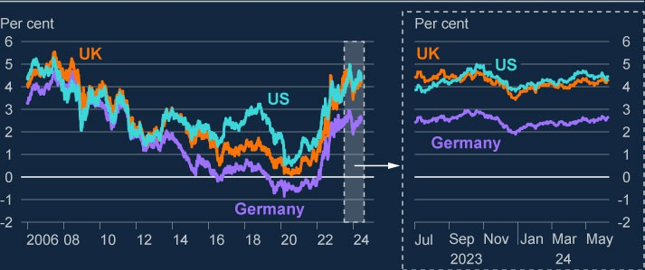

**Chart 1.1: Longer-term borrowing costs remain high relative to post-global financial crisis levels, and are broadly unchanged since the December FSR**

US, UK and German 10-year government bond yields

Source: Bloomberg Finance L.P.

##### Core market functioning has improved as interest rate volatility has fallen back towards historical averages.

Core markets have functioned well since the previous FSR. Measures of liquidity across UK government bond markets has improved. Bid-ask spreads have narrowed. Sterling money markets have also operated well, with trading rates and volumes generally remaining within historical norms.

Market contacts suggest the global improvement in core market functioning has been driven by reduced interest rate volatility. The MOVE index, which tracks implied volatility in US Treasury markets, has continued to trend lower since December and is now around its average since 1990. Contacts attribute the fall to reduced perceived uncertainty over the

global outlook.

##### Risk premia across a range of markets have fallen significantly since December and are now low by historical standards.

Prices of a range of risky assets – those which carry a degree of credit risk over government securities – have risen since the December FSR. With long-term interest rates remaining high, and the outlook for growth only improving slightly, this increase in prices has been primarily driven by falling risk premia. Measures of risk premia across a range of different asset classes, including equities and corporate debt, are now further below historical medians (Chart 1.2). Relative to the December FSR, risk premia for a broader set of asset classes now appear compressed.

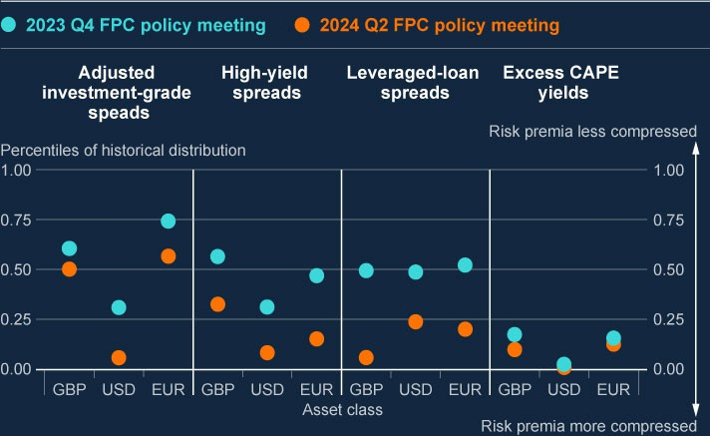

**Chart 1.2: Risk premia across many asset classes have fallen further and appear compressed relative to their historical distributions (a)**

Current level of selected risk premia metrics as a percentile of historical distribution, compared to levels seen at the 2023 Q4 FPC policy meeting

Sources: Bloomberg Finance L.P., Datastream from LSEG, ICE BofAML, Leveraged Commentary & Data (LCD), an offering of pitchbook and Bank calculations.

(a) Risk premia data are a percentile of five-day rolling average (except for leveraged-loan (LL) spreads). Percentiles are calculated from 1998 for investment-grade spreads and high-yield bond spreads, 2008 for LL spreads and 2006 for excess cyclically-adjusted price-to-earnings (CAPE) yields. Data updated to 10 June 2024, except for LL spreads which are updated to 7 June 2024. Investment-grade spreads are adjusted for changes in credit quality and duration. All data is daily except for LL spreads which are weekly.

Equity price growth has been particularly strong for some time in the US, driven by the continued resilience of the US economy and optimism over future returns due to Artificial Intelligence and other technological developments. Prices have continued to increase since December and risk premia remain very low by historical standards. The excess cyclically adjusted price-to-earnings yield – a measure of the excess return that investors expect from equities relative to government bond yields – on US equities is at a similar level to the early 2000s. Equity indices have also risen in the UK and EU since the December FSR, notwithstanding a recent fall in French equities. The ratio of prices to earnings over the previous 12 months has increased across these markets but remains below early 2000s peaks.[2]

Corporate credit spreads to risk free rates have also tightened materially since December, with spreads falling across most types of corporate lending. This is particularly evident in the US, where corporate spreads are now nearing levels last seen pre-2008. Spreads on high- yield bonds and leveraged lending also appear historically compressed across jurisdictions, with the majority in or around the bottom quartile of their historical distribution (Chart 1.2).

The tightening of credit spreads has been driven by generally strong investor risk appetite, evident in robust primary market issuance. Corporate debt issuance has been strong in the year to date (Chart 1.3). Most market contacts are more optimistic about the global outlook and think aggregate corporate credit risk is receding. While defaults have been rising, most contacts believe default rates have peaked, consistent with ratings agency central case projections.

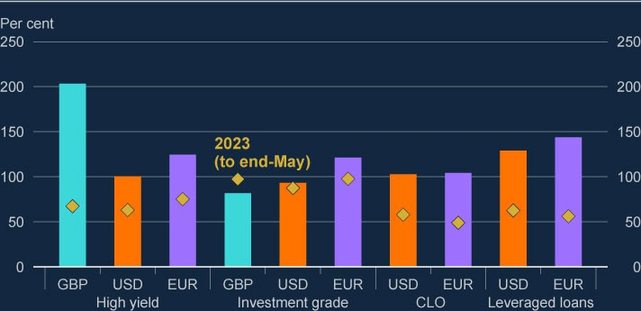

**Chart 1.3: Corporate issuance in the year to date has been strong across most credit markets (a) (b) (c)**

Year-to-date credit issuance compared to previous five-year average (2019–2023)

Sources: Leveraged Commentary & Data (LCD), an offering of pitchbook, Refinitiv Eikon from LSEG and Bank calculations.

1. Monthly data as at 31 May 2024.
2. Yellow diamond data as at 31 May 2023.
3. Data for both columns and yellow diamonds are a percentage of the 2019–2023 year to date cumulative averages. For example, a percentage above 100 indicates above average issuance.

There remains some evidence of investors demanding higher risk premia in certain asset classes. Contacts report that demand for some of the riskiest debt has not recovered as much as for more highly rated corporates. This is reflected in the pricing of the lowest rated high- yield debt. For example, while overall euro-denominated high-yield spreads have fallen around 120 basis points since the previous FSR and are around the 15th percentile of their

historical distribution, lower-rated euro-denominated high-yield spreads (rated CCC or lower) are around the 75th percentile. The divergence in pricing of the lowest rated bonds is also evident in the smaller sterling market, and in US dollar high-yield debt (Chart 1.4).

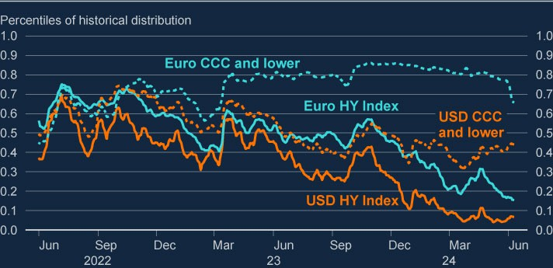

**Chart 1.4: Risk premia on lower-rated high-yield bonds have not fallen by as much as those on other high-yield bonds, relative to their historical distributions (a)**

US dollar and euro-denominated high-yield bond spreads, total index and CCC and lower rated, as a percentile of their historical distribution

Sources: ICE BofAML and Bank calculations.

1. Percentiles calculated as five-day rolling average since 1999.

##### The widespread compression of risk premia has increased the risk of a sharp re-

**pricing across asset markets. Such a correction could impact financial stability via a number of channels.**

Although financial market asset valuations have so far been robust to large increases in interest rates and recent geopolitical events, the adjustment to the higher interest rate environment is not yet complete. The FPC judges that risk premia and valuations remain particularly vulnerable to a shift in risk appetite. An adjustment could be triggered by factors including a weakening of growth prospects, more persistent inflation or a further deterioration in geopolitical conditions.

Should these downside risks materialise, a change in sentiment could lead to a sharp correction in market prices, adversely affecting financing to the real economy via two main channels. First, it would make it more costly and difficult for corporates to refinance maturing debt, including by reducing the value of collateral. This is particularly relevant given the large proportion of leveraged lending and high-yield market-based corporate debt that is due to mature by the end of 2025. Second, it could interact with vulnerabilities in market-based

finance which may amplify the correction. For example, it may cause large losses for leveraged market participants, which could further reduce risk appetite and trigger further deleveraging. Or it may lead to a spike in liquidity demand and a deterioration in the functioning of core markets.

# 2: Global vulnerabilities

### Key developments since the December 2023 FSR

Global vulnerabilities remain material. Households, businesses, governments and financial institutions across jurisdictions continue to adjust to higher interest rates. Policy uncertainty associated with upcoming elections globally has increased. This

could increase existing sovereign debt pressures, geopolitical risks, and risks

associated with global fragmentation. It could also make the global economic outlook less certain and lead to financial market volatility.

Risks are crystallising in commercial property markets globally. US commercial real estate (CRE) borrowers have significant short-term refinancing needs and a number of overseas banks with large exposures to CRE, in the US and other jurisdictions, experienced significant falls in their equity prices earlier in the year. Stresses in

global CRE markets could spill over to the UK through several channels. Spillovers to UK financial stability from the adjustment in the mainland China property market remain limited so far, but significant downside risks remain.

The 2022/23 Annual Cyclical Scenario (ACS) stress test indicated that major UK banks can continue to serve the UK real economy in a severe global stress including elevated interest rates and very significant falls in real estate prices.

### : The global economic outlook

##### Global growth is expected to remain modest over the near term.

There were notable differences in growth across jurisdictions over 2023, with growth stronger in the US and weaker in the euro area. Over 2024, the projections in the May Monetary Policy Report (MPR) are for four-quarter growth to pick up in the euro area, and to moderate somewhat in the US, albeit from relatively high levels. Overall, global activity is expected to

grow at moderate pace.

Inflationary pressures have moderated across many advanced economies, and headline and core inflation have fallen back from their peaks over the past year. The European Central Bank and the Bank of Canada both reduced policy rates in June, and market participants expect other central banks, including the Federal Reserve Bank and the Bank of England, to begin to reduce rates over the coming quarters. However, market participants expect short- term interest rates to remain higher for longer over 2024 than was expected at the time of the December FSR.

### : The continued impact of higher interest rates

Policy rates in advanced economies have increased significantly over recent years, and households, businesses, sovereigns and financial institutions continue to adjust. Higher interest rates, while necessary to reduce inflation, could impact UK financial stability in a number of ways (see [**Financial Stability in Focus: Interest rate risk in the economy and**](https://www.bankofengland.co.uk/financial-stability-in-focus/2023/july-2023)[**financial system**](https://www.bankofengland.co.uk/financial-stability-in-focus/2023/july-2023)for details).

##### Risks have started to crystallise in property markets globally.

CRE prices have continued to decline since the December FSR in many countries, and are below their pre-Covid levels in the UK and euro area (Chart 2.1). This reflects the continued effect of higher interest rates, as well as structural factors such as the shift to more remote working, and falls in the prices of some buildings driven by differences in energy efficiency. The continued impact of higher interest rates, increasing vacancy rates in certain parts of the sector, and tightening in CRE lending standards are likely to continue to drag on CRE prices globally.

CRE borrowers face large short-term refinancing needs, particularly in the US. Around US$1 trillion of US CRE debt is due to mature in 2024 and 2025, with around a quarter of all debt backed by offices or by industrial property estimated to mature in 2024. A portion of this

debt had been due to mature in 2023, but has since been extended or otherwise modified. Of the US$1 trillion of US CRE debt maturing in 2024 and 2025, the International Monetary Fund (IMF) estimates the gap between demand for finance and the amount that lenders are willing to provide (the ‘refinancing gap’) to exceed US$300 billion, based on current pricing and prevailing CRE debt market conditions. This could lead to further sales of CRE assets if investors are unable to roll over or secure new financing, potentially amplifying falls in CRE prices.

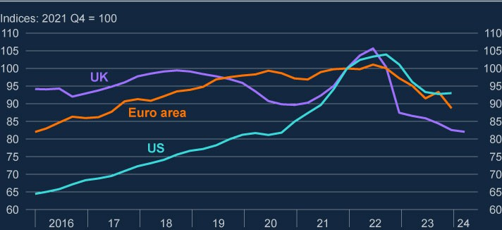

**Chart 2.1: CRE prices continue to fall across regions**

Indexed CRE prices in the UK, euro area and US (**a**)

Sources: European Central Bank, Federal Reserve Board, MSCI and Bank calculations.

(a) Data used are latest available as at 10 June. More recent data are available for the UK than for the US or euro area.

##### Stress in global commercial property markets could spill over to the UK.

The global banking system has significant exposures to CRE. For instance, the IMF estimates that CRE debt accounts for about 18% of total US bank loans. Of the debt due to mature over 2024 and 2025, banks hold a larger proportion than other types of lenders. The non- performing loan ratio for CRE lending in the US and in the euro area increased over 2023, and the proportion of UK banks’ CRE loans considered credit impaired also increased. US CRE loans secured on office buildings in particular have seen marked increases in delinquencies over 2023 and 2024.

There are a number of small and mid-sized banks in jurisdictions such as the US, Germany and Japan with significant domestic and cross-country exposures to CRE. Some banks saw sharp falls in stock prices after announcing losses or provisions on CRE portfolios earlier this year, and one small US bank with large CRE exposures failed in April.

The results of the 2022/23 ACS stress test, which included very sharp falls in global property prices well beyond those seen to date, suggest that major UK banks are resilient to their direct exposures to commercial real estate globally. Losses on CRE exposures reduced

aggregate CET1 ratios of major UK banks by 0.3 percentage points in the 2022/23 ACS. However, crystallisation of risks in global CRE markets could pass through to the UK financial system in other ways.

A significant share of global CRE debt and exposure to property markets is held outside the banking sector. Outflows from CRE funds have continued, though these have so far been orderly. There is less visibility on CRE debt held by non-bank financial institutions (NBFIs), but correlated exposures to overseas CRE markets for some groups of NBFIs could lead to concentrated losses in a stress.

Stresses in exposed non-banks, as well as in overseas banks, could affect UK financial stability through macroeconomic and financial market spillovers, contagion to funding conditions for UK banks, or a reduction in overseas finance for the UK CRE sector leading to further downward pressure on UK valuations. Stress could also interact with existing vulnerabilities in the system of non-bank finance.

##### Growing expected interest rate differentials with the US have generated moves in exchange rates and, in some places, increased financial pressures.

Policy rates in the US are now expected to remain higher for longer than at the time of the December FSR, and interest rate differentials between the US and a number of other countries have generated moves in exchange rates. For instance, the yen has depreciated to historic lows against the US dollar, prompting intervention in the foreign exchange markets by the Japanese authorities.

Non-China emerging market economies have experienced increased financial pressure from exchange rate differentials, but have generally continued to be resilient. If global financial conditions were to tighten sharply, non-China emerging market assets could be subject to a sudden repricing, which could have spillovers to the UK through financial markets.

##### Banks continue to adjust to higher interest rates across jurisdictions, but vulnerabilities remain.

US and euro-area bank profitability has generally been supported by higher interest rates. Deposits in smaller US banks have returned to levels seen before the March 2023 stress (Chart 2.2).

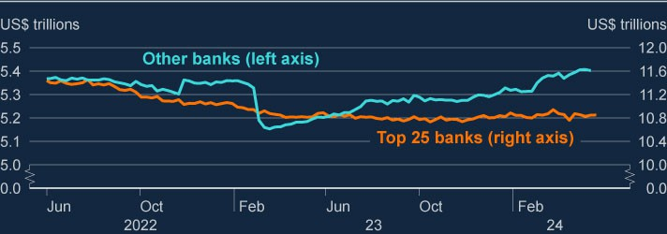

**Chart 2.2: Smaller US banks’ deposit levels have returned to levels seen before March 2023**

Deposit levels at US banks, seasonally adjusted

Source: Refinitiv Eikon from LSEG.

However, a number of vulnerabilities remain, particularly among small and mid-sized US banks. Banks are still exposed to sectors such as CRE that are adjusting to a higher interest rate environment. In March, the Federal Reserve’s Bank Term Funding Program (BTFP) ceased extending new loans, though the Federal Reserve’s discount window lending programmes are still available to help banks manage liquidity risks. 95% of advances provided through the BTFP were given to smaller institutions.

Some banks across jurisdictions continue to face high unrealised losses on securities including bonds, brought about by the increase in interest rates. US banks’ total unrealised losses on securities were US$39 billion higher in 2024 Q1 than at the end of 2023, at US$517 billion. Further rises in foreign and domestic yields could also generate further unrealised losses on debt security holdings across some Japanese banks.

The overseas banking stress following the failure of Silicon Valley Bank in March 2023 showed that stress can spread across and within jurisdictions, even where smaller institutions are involved. It highlighted that, while an individual institution may not be considered systemic, if a risk is common – or perceived to be common – among similar institutions, the collective impact can pose a systemic risk. Further losses on CRE or other exposures could spill over to other markets if similar contagion dynamics were to occur, including through market or depositor sentiment.

##### Globally, corporate and household balance sheets have remained resilient in aggregate despite pressures from higher costs of servicing debt.

Higher interest rates continue to make it more challenging for households and businesses to service and refinance their debts, but corporate and household balance sheets have remained resilient in aggregate across advanced economies.

There are however some areas of increased vulnerability, including borrowing by highly leveraged corporates. Defaults on leveraged loans increased to a peak of 7.1% globally in February, and were at 6.8% in April, up from 5.0% this time last year. And as outlined in Section 6, private credit and leveraged loan markets are interconnected and shocks could be highly correlated, so disruptions in overseas markets could spill over to the UK.

##### Public debt-to-GDP levels have increased across a number of major economies, which could have consequences for UK financial stability.

Across jurisdictions, debt-to-GDP levels have increased over recent years, driven by increased government borrowing, particularly over the Covid pandemic. The current period of elevated geopolitical risk and uncertainty, as well as structural trends such as demographics, could place further pressure on debt-to-GDP levels and government finances.

The FPC has previously highlighted vulnerabilities created by high public debt levels in major economies, including through interlinkages between banks and sovereigns. Increases in

global policy rates, combined with increasing indebtedness levels, have increased the costs of servicing government debt. And higher interest rates will further increase debt servicing costs over time as governments refinance.

High public debt levels in major economies could have consequences for UK financial stability and interact with other risks. A deterioration in market perceptions of the path of public debt globally could lead to market volatility and interact with vulnerabilities in market-based finance, potentially tightening credit conditions for households and businesses. Increased servicing costs for governments as debt is refinanced could also reduce their capacity to respond to future shocks. The FPC will continue to monitor these risks and take into account the potential for them to crystallise other financial vulnerabilities and amplify shocks.

### : Risks from developments in China

##### Property market vulnerabilities in mainland China have continued to crystallise.

Activity in the mainland Chinese residential property sector continues to decrease, and prices of new and existing homes have fallen over 2024 (Chart 2.3). Some large Chinese property developers have missed bond payments without agreed extensions. In response to property market developments, Chinese authorities have put in place measures to provide support and limit spillovers from the property sector to the broader economy, and further measures were

announced in May to support housing demand and encourage state-owned enterprises to purchase unsold properties. Disorderly defaults by property developers have been avoided thus far.

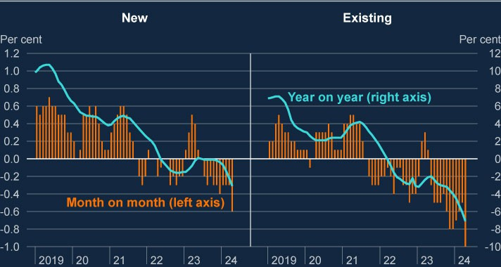

**Chart 2.3: Residential property prices in mainland China have continued to decline over 2024**

Year-on-year, and month-on-month, changes in new (left panel) and existing (right panel) residential property prices in mainland China (**a**) (**b**)

Source: Refinitiv Eikon from LSEG.

1. These data show the Sales Price Indices of residential buildings in 70 large and medium-sized cities.
2. New homes comprise the majority of residential property sales in China, but this market is subject to tighter restrictions on price adjustments.

The adjustment in the property sector, alongside broader structural trends, is likely to weigh on growth in China for some time. Property accounts for a significant proportion of household wealth in China; much higher than in the US, for example. That means falls in sales and

residential property prices are likely to continue to impact Chinese consumption and growth.

There have been limited spillovers to the UK so far from the adjustment in mainland China’s property market. However, significant downside risks remain. More widespread crystallisation of risks in mainland China could lead to spillovers to the UK and other countries, and could be

larger if the crystallisation of property sector vulnerabilities were to spread to other sectors in the Chinese economy. Risks could spill over to the UK financial system through channels including weaker trade, financial markets, and global risk sentiment.

UK banks are more heavily exposed to the Hong Kong property market, where property prices have also fallen as higher interest rates have continued to feed through, in part linked to the

currency’s peg to the US dollar. Latest Hong Kong Government data suggests residential real estate prices decreased by 13% year on year in April 2024, and CRE prices by 13% year on year in March 2024. The property sectors in mainland China and Hong Kong are separate and prices are driven by different factors, but a significant slowing of the mainland Chinese economy might be expected to affect Hong Kong property prices. The 2022/23 ACS indicates that major UK banks would be resilient to very significant declines in property prices in mainland China and Hong Kong, with residential property price declines of more than 30% and 40% respectively.

### : Geopolitical risks

##### Policy uncertainty associated with upcoming elections globally has increased.

Policy uncertainty could increase existing sovereign debt pressures and interact with pressures on public sector debt levels in major economies, geopolitical risks, and risks associated with global fragmentation. These factors and their potential interaction make the economic outlook less certain and could lead to market volatility, including in sovereign debt markets, as already observed in response to the unexpected news of French parliamentary elections over the summer.

##### Geopolitical risks remain high and could impact the UK financial system through a number of channels.

Events in the Middle East, Russia’s continued war in Ukraine, and US-China relations all represent sources of material geopolitical risk. Geopolitics is consistently cited by market participants as a key risk to financial stability; geopolitical risks were the most commonly cited ‘number one’ source of risk in the [**2024 H1 Systemic Risk Survey**](https://www.bankofengland.co.uk/systemic-risk-survey/2024/2024-h1). Market intelligence indicates that financial market participants are taking a range of approaches in response to these risks, including reducing and restructuring exposures and increasing investment in insurance against losses from unlikely events. But market participants also noted that these risks are difficult to manage given the unpredictability of their timing and impact.

There are a number of channels through which UK financial stability could be affected by geopolitical developments, including by increasing the likelihood of other vulnerabilities

discussed in this report crystallising. For example, developments in the Middle East, including disruption to shipping through the Red Sea, or further escalation of conflict in Ukraine, could disrupt global trade and supply chains and cause sharp moves in commodity prices. Such

moves can lead to rapid increases in liquidity demand in the system of market-based finance (see Section 5). Should they crystallise, further shocks to energy prices could lead to higher inflation and upward pressure on interest rates, increasing challenges for households and businesses (see Section 3). And crystallisation of geopolitical risks could worsen existing sovereign debt pressures and so impact core financial markets, or trigger a correction in broader asset prices (see Section 1).

If a number of vulnerabilities were to crystallise together, or the financial market or macroeconomic impact were large enough, this has the potential to disrupt UK financial stability. The FPC continues to monitor these risks.

# 3: UK household and corporate debt vulnerabilities

### Key developments since the December 2023 FSR

Household and corporate borrowers as a whole have been resilient to higher interest rates. But many UK households, including renters, and businesses remain under pressure from the higher cost of living, subdued demand and higher interest rates.

Higher mortgage rates will, in aggregate, continue to pass through to mortgagors as their fixed-rate mortgages expire and they refinance. The share of households in arrears or with high debt-servicing burdens is expected to increase further but should remain well below previous peaks.

Some corporates are yet to refinance debt onto higher rates. Highly leveraged UK firms using market-based finance (see Section 5), including those backed by private equity (see Section 6), are likely to face greater refinancing challenges. These challenges would increase if investor risk appetite deteriorates, or if interest rates remain higher for longer than markets expect.

The FPC continues to judge that, in aggregate, the UK household and corporate sectors are likely to remain broadly resilient to the current economic outlook, including high interest rates.

##### Household and corporate indebtedness can impact UK financial stability through two key channels.

The FPC previously identified two main channels through which high levels of household and corporate debt can pose risks to the UK financial system:

1. Lender resilience: If highly indebted households and businesses get into difficulties making debt repayments and default, this can lead to losses for lenders and test their resilience.
2. Borrower resilience: Highly indebted households and businesses may cut back sharply on consumption, investment or employment to make debt repayments, and hence amplify macroeconomic downturns and losses for lenders.

Both borrower and lender resilience can be adversely affected by several factors, including higher debt-servicing costs and lower business and household incomes. If lower incomes were associated with higher rates of insolvency and unemployment, that would be likely to have a more marked impact on lender resilience.

### : Overview of UK economic developments

##### The macroeconomic outlook has improved since the December FSR. But many households, including renters, and businesses remain under pressure from past increases in the cost of living, subdued demand and higher interest rates.

In the [**May MPR**](https://www.bankofengland.co.uk/monetary-policy-report/2024/may-2024), annual real UK GDP growth was projected to average around 1.2% over the three-year forecast period. Consistent with that, UK unemployment was projected to remain

low by historical standards, remaining below 5% through to 2026 Q4. CPI inflation has continued to fall back to the MPC’s target since the December FSR.

Household incomes and corporate earnings continued to increase in aggregate over the second half of 2023. Household nominal income growth slowed slightly in 2023 Q4 but rose by 5.3% over 2023 as a whole. With inflation falling, aggregate real incomes and the household savings ratio continued to recover. Corporate earnings also increased robustly, growing by around 7% in 2023. But not all households and businesses will have experienced those rates of income and earnings growth.

The UK House Price Index shows that house prices have remained broadly flat over the year to 2024 Q1 and are 0.3% below their peak in November 2022. While they remain 24% above 2019 levels, they have declined relative to incomes. Indicators suggest prices will remain broadly stable in the near term. Quoted mortgage rates have fallen slightly since the December FSR, with two-year and five-year fixed rate 75% loan to value (LTV) mortgages

now at around 4.7% and 5.2% respectively, but they remain well above pre-2022 levels. Mortgage approvals have continued to recover, although they remain a little below pre- pandemic levels.

### : UK household debt vulnerabilities

##### The aggregate household debt to income ratio continues to trend down.

Aggregate measures of UK household indebtedness have continued to fall since the December FSR, driven by the growth in nominal incomes. The aggregate household debt to income ratio fell by 1.3% in 2023 Q4, having also fallen by 1.3% in 2023 Q3. Consistent with this, many borrowers report an increase in their savings buffers. The 2024 Q1 NMG household survey also indicates that indebted households believe their financial outlook has improved. These developments suggest the risk that indebted households would materially amplify a shock by cutting spending sharply, because of their debt-servicing commitments, has reduced.

##### But many mortgagors coming to the end of fixed-rate deals will see increased borrowing costs as they have yet to refinance onto higher rates.

While most fixed-rate mortgages have repriced since mortgage rates started to rise in 2021 H2, the full impact of higher interest rates has not yet passed through to all mortgagors. Over three million, or 35%, of mortgage accounts are still paying rates of less than 3%; the majority of whom will have their fixed rate expire before end-2026. For the typical owner-occupier mortgagor rolling off a fixed rate between June 2024 and end-2026, their monthly mortgage repayments are projected to increase by around £180, or around 28% (Chart 3.1). Within that average, a relatively small proportion are likely to experience some very large increases – around 400,000 households will see an increase in their payment of 50% or more.

Offsetting some of that refinancing pressure, market participants expect Bank Rate to start falling in 2024 H2. This would immediately benefit variable rate mortgagors, who account for around 18% of the total stock of mortgages. Current market pricing also suggests a growing number of fixed-rate mortgagors, who are already paying higher rates, may be able to refinance at a lower interest rate over the next two years (Chart 3.1). In response to higher mortgage rates, an increasing proportion of households are choosing to borrow over longer terms, which reduces monthly capital repayments in the near term but means they will have more debt to service further out.

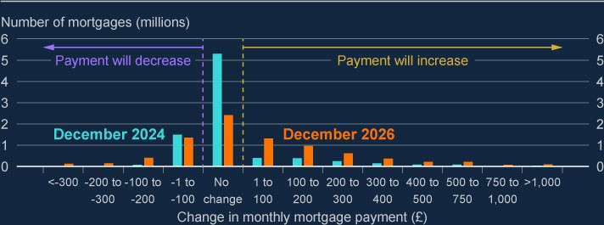

**Chart 3.1: Around 30% of mortgagors are likely to see mortgage costs rise by more than £100 a month by end 2026**

Number of owner-occupier mortgages by estimated change in monthly mortgage costs, by December 2024 and December 2026 (**a**) (**b**) (**c**)

Sources: Bloomberg Finance L.P., FCA Product Sales Data and Bank calculations.

1. The projection uses the overnight index swap (OIS) curve as at 10 June 2024 and the latest available data (end-2023) on the stock of outstanding mortgages.
2. Changes in payments on variable-rate mortgages are calculated using the implied change in the OIS curve, and changes in payment on fixed-rate mortgages are calculated by assuming that mortgagors refinance onto a typical fixed rate implied by the OIS curve at the point that their fixed-rate contract ends.
3. Mortgages with less than £1,000 outstanding are excluded. These data do not include buy-to-let mortgages or mortgages that are off balance sheet of authorised lenders, such as securitised loans or loan books sold to third parties.

##### Although debt-servicing ratios (DSRs) are increasing, mortgagors should remain broadly resilient to higher interest rates if unemployment remains low, as projected by the MPC.

The continuing adjustment to higher interest rates means that, in aggregate, the share of household income spent on mortgage repayments is likely to increase further, as it has done since the December FSR, albeit to a lesser extent than expected. The aggregate mortgage DSR is still projected to remain well below levels experienced in the global financial crisis (GFC) and the early 1990s recession (Chart 3.2). Borrowing rates would likely have to increase by around 400–500 basis points for mortgage DSRs to reach GFC levels.

The share of households with high mortgage DSRs is also expected to increase slightly over the next two years. The proportion of all households with high mortgage cost of living adjusted DSRs (COLA-DSRs over 70%) is projected to increase from 1.5% in 2024 Q1 to 1.6% in 2025 Q4, which is similar to the projection at the time of the December FSR.[3] NMG household survey evidence suggests these households have seen their savings buffers fall in the past

year, making them more vulnerable to shocks than other groups of mortgagors whose buffers have generally increased. Nevertheless, the proportion of vulnerable mortgagors is expected to remain well below pre-GFC levels if unemployment remains low, consistent with the MPC’s central projection.

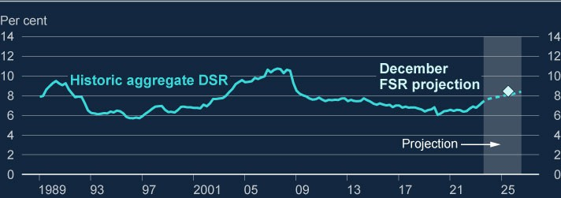

**Chart 3.2: The aggregate debt-servicing burden for mortgagors is expected to increase by less than at the time of the December FSR and remain below past peaks** Aggregate household mortgage debt-servicing ratio (DSR) and staff projections (**a**) (**b**)

Sources: Bank of England, Bloomberg Finance L.P., FCA Product Sales Data, ONS and Bank calculations.

1. Calculated as mortgage interest payments plus principal repayments as a proportion of nominal household post-tax income. Household income is defined as disposable (post-tax) income adjusted for changes in pension entitlements, which is adjusted to exclude gross operating surplus and the effects of financial intermediation services indirectly measured, and to add back in interest paid. Mortgage interest payments before 2000 are adjusted to remove the effect of mortgage interest relief at source.
2. For the illustrative projections to mid-2027, projections for household post‑tax income consistent with the [**May 2024 MPR.**](https://www.bankofengland.co.uk/monetary-policy-report/2024/may-2024)Payment increases are projected using market expectations for Bank Rate based on the OIS curve as at 10 June 2024, taking into account the distribution of fixed-deal terms from the FCA Product Sales Data and assuming the aggregate mortgage debt to income ratio remains constant.

Mortgage arrears have been broadly flat since the December FSR, with the share of owner- occupier mortgages in arrears around 1.1% in 2024 Q1.[4] This remains low in historical terms, with robust nominal wage growth and low unemployment over recent quarters helping contain the rise. While arrears are expected to increase further, they are likely to remain well below their early 1990s and post-GFC peaks of 4.0% and 2.4%, respectively. This is despite interest rates having risen by more since 2021 Q4 than in past tightening cycles.

The FPC’s mortgage market measures, introduced in 2014, have boosted the resilience of the UK household sector by helping to limit the build-up of household indebtedness in the mortgage market and so helped reduce payment difficulties for mortgagors. This includes the

15% flow limit on new lending to borrowers with high loan to income (LTI) ratios (at or greater than 4.5). More than half of the mortgages currently in arrears were originated prior to 2008. The FCA’s Mortgage Conduct of Business (MCOB) rules also continue to guard against the risk that mortgage repayments become unaffordable. Robust bank capital and profitability, as well as regulatory conduct standards for lenders overseen by the FCA, mean UK banks are both able and expected to offer forbearance and support to borrowers concerned at the impact of the increase in their repayments. This is reflected in low repossession rates, which are currently at around 0.03%, well below their 2009 rate of 0.2% and their 1990s peak of 0.7%.

Banks continue to have capacity for new high LTI lending up to the 15% flow limit, with evidence suggesting accumulating a sufficient deposit remains a key challenge for first-time buyers. In aggregate around 5% of new mortgage lending was at high LTI ratios in 2024 Q1, well below the FPC’s flow limit.

In the 2022/23 annual cyclical scenario (ACS), major UK banks were stress tested against a severe macroeconomic scenario, which included unemployment rising to 8.5%, which would put pressure on the ability of households to service their debts. The results indicated that they would be able to continue to support households and were resilient to significant losses on consumer credit and mortgage lending.

##### But pressures on renters and lower income households continue.

While the position of households in aggregate appears to be resilient, pressures associated with continued higher interest rates and living costs continue and will be concentrated in a subset of households. Savings buffers for renters and low-income households have been further eroded in the six months to 2024 Q1. NMG survey evidence suggests the share of renters who have fallen behind on payments has also increased slightly to 16.5% in 2024 Q1 from 15.7% in 2023 Q1, as rents have risen substantially alongside the increase in mortgage borrowing costs. Average UK private rents increased by 8.9% in the 12 months to April 2024.

The NMG survey also suggests many renters and lower-income households intend to run down their savings even further in the next year to deal with the increased cost of living, making these groups less financially resilient. Consistent with this, third-sector organisations have noted that a significant number of lower-income households are relying on consumer credit for essentials.

Consumer credit remains an important determinant of household debt financing burdens. Compared to mortgages, consumer credit lending normally has significantly shorter terms and higher interest rates and is more likely to be held by low-income households.

Direct financial stability risks from consumer credit are likely to remain limited given the current outlook. Consumer credit debt remains low as a share of aggregate household income. While consumer credit arrears have increased a little since the December FSR, to 1.3% in 2024 Q1, they remain low by historical standards. Consumer credit lending makes up a relatively small share of bank exposures, compared to mortgages. However, impairment rates are typically higher on consumer credit lending, and would be more sensitive to rises in unemployment, compared to other exposures. As such, in the event of a macroeconomic downturn, a greater impact would be felt by those lenders whose exposures were concentrated in consumer credit or to higher-risk borrowers. Consumer credit lending from non-banks has also grown since the pandemic. The FPC welcomes the FCA’s plans to establish more comprehensive data across all types of consumer credit lending, which should enable the FCA and FPC to monitor potential harms and financial stability risks from the consumer credit market more effectively.

### : UK corporate debt vulnerabilities

##### Measures of indebtedness suggest corporate resilience continues to improve in aggregate.

Corporate debt to earnings declined by 8% over 2023, having fallen by 7% over 2022. This was largely driven by robust earnings growth while aggregate nominal debt and cash holdings remained broadly flat. The latest data covering 2023 Q4 show that the corporate gross debt to earnings ratio stood at around 280%, down from 345% in 2020 Q4. The net debt to earnings ratio remained at its lowest point in the last 20 years at around 120% (Chart 3.3). This has reduced the risk that indebted corporates would materially amplify a shock. However, earnings, cash reserves and debt holdings are not evenly distributed among firms, so this aggregate picture can mask vulnerabilities within particular firms and sectors.

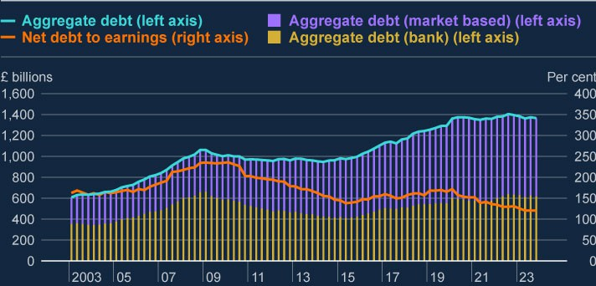

**Chart 3.3: The aggregate net corporate debt to earnings ratio has continued to fall**

Aggregate debt of UK corporates split into bank and market-based debt (left axis). Aggregate net debt to earnings ratio of UK corporates (right axis) (**a**)

Sources: Association of British Insurers, Bank of England, Bayes CRE Lending Report (Bayes Business School (formerly Cass)), Deloitte, Finance & Leasing Association, firm public disclosures, Integer Advisors estimates, LCD an offering of Morningstar London Stock Exchange, LSEG Eikon, ONS, Peer-to-Peer Finance Association and Bank calculations.

(a) These data are for private non-financial corporations (PNFCs), which exclude public, financial and unincorporated businesses. Earnings are defined as businesses’ aggregate gross operating surplus, adjusting for financial intermediation services indirectly measured.

##### Although the share of vulnerable corporates has increased slightly, it is projected to continue to remain well below past peaks.

The debt-weighted proportion of corporates with low interest coverage ratios (ICRs) – ICRs

below 2.5 – has increased slightly in the latest data available. It is expected to increase further to around 47% at end-2025, some way below previous peaks (Chart 3.4). This is consistent with the Bank’s broader corporate [**debt at risk**](https://bankunderground.co.uk/2024/02/21/stressed-or-in-distress-how-best-to-measure-corporate-vulnerability/)measure based on data up to end-2023 (Chart 3.5). This measures the share of debt held by firms that cross three thresholds with the highest predictive power for default: low ICRs; low liquidity; and negative return on assets.

These firms are considered to be at higher risk of default, and more likely to take defensive actions such as significantly cutting investment and employment, creating risks through the borrower resilience channel. The estimated share of corporate debt at risk has ticked up slightly in 2023, but remains below 10%, suggesting that the volume of vulnerable corporates remains well below the GFC and early 2000s peaks.

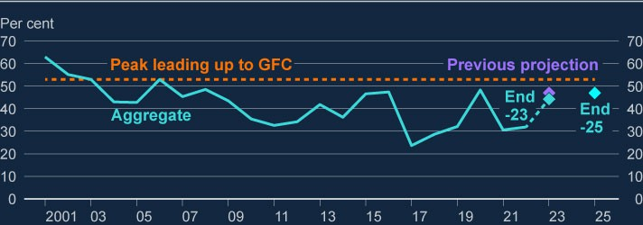

**Chart 3.4: The debt-weighted share of vulnerable UK companies is projected to remain below past peaks**

Debt-weighted share of UK corporates with ICRs below 2.5 versus GFC peak (**a**) (**b**)

Sources: Moody’s: Bureau van Dijk, S&P Capital IQ and Bank calculations.

1. These data refer to UK PNFCs only.
2. The projection uses the expected pass-through of higher interest rates to the stock of corporate debt and the increase in Bank Rate over 2023. These assumptions are applied to latest (end-2022) published balance sheet data to produce estimates for end-2023 and end-2025.

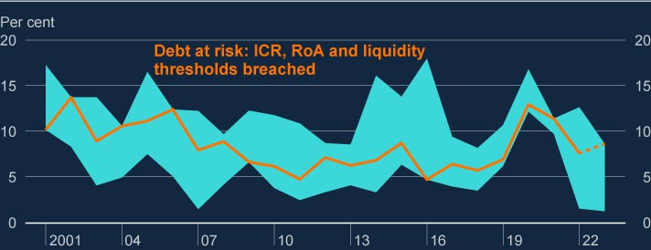

**Chart 3.5: The share of UK corporate debt at risk remains well below past peaks**

Debt-weighted share of UK corporates at higher risk (**a**) (**b**) (**c**)

Sources: Moody’s: Bureau van Dijk and Bank calculations.

1. The orange line represents the debt-weighted share of UK corporates that simultaneously breach the three thresholds associated with the highest likelihood of firm failure: whether a company’s interest coverage ratio, calculated by dividing its earnings before interest and tax, is below 1.5; whether its liquidity ratio (current ratio) is below 1.1; and whether its return on assets is negative.
2. Alternative projections of debt at risk within the aqua swathe capture firms that breach any three thresholds within six factors (the three set out in (a), as well as turnover growth less than -5%, leverage growth greater than 5% and leverage less than 1) and breach the thresholds with the highest marginal effects. See [**Stressed or in distress? How best to measure**](https://bankunderground.co.uk/2024/02/21/stressed-or-in-distress-how-best-to-measure-corporate-vulnerability/)[**corporate vulnerability**](https://bankunderground.co.uk/2024/02/21/stressed-or-in-distress-how-best-to-measure-corporate-vulnerability/)for further details.
3. This chart includes available data from end-2023 balance sheets. But not all firms have submitted end-2023 balance sheets, so the partial coverage beyond 2022 is represented in the chart as a dotted line.

##### But refinancing challenges remain, particularly for firms using riskier market-based finance markets, such as leveraged loans and high-yield bonds.

Given that most corporate debt is on floating interest rates (eg variable rate bank loans) that have already increased in line with Bank Rate, much of the debt-servicing pressure associated with past interest rate rises has already passed through to corporates in aggregate.

But a subset of corporates, largely those relying on market-based finance (or with interest rate hedges in place), have not yet felt the full impact of higher interest rates. Most UK corporate bonds have fixed repayments. Corporate bonds currently account for 25% of total UK corporate debt. Given the average tenor of UK corporate bonds is around 10 years, most of these bonds were issued before interest rates started to rise. Many bonds issued in 2014,

when UK high-yield corporate bond interest rates were around 4.9% on average, may be reaching maturity in 2024 and if they need to be refinanced, it would be at around the current market average rate of around 8.9%.

While strong issuance in corporate debt markets over the past 12 months has supported refinancing (see Chart 1.3), around 25% of corporate bonds issued by UK companies are due to mature in the next two to three years.

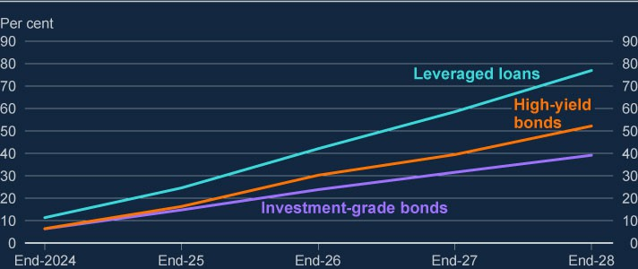

**Chart 3.6: A large proportion of higher-risk fixed-term market-based debt used by UK firms is due to be refinanced in the coming years**

Cumulative share of debt maturing by type (**a**)

Sources: Refinitiv Eikon from LSEG and Bank calculations.

1. The chart captures market-based finance debt issued in all currencies by UK corporates, both UK issuer with a UK parent and UK issuer with a non-UK parent. Annual estimates.

More highly rated or less leveraged firms are likely to be more resilient to refinancing risks. They tend to have stronger balance sheets and more choice over sources of finance.

Investment-grade bonds account for a relatively small proportion of maturing market-based debt over the coming years.

Near-term refinancing requirements are higher in markets for riskier borrowers, where terms tend to be shorter. Notably, around 16% of high-yield corporate bonds are due to mature by end-2025, and around 40% by end-2027 (Chart 3.6). Many of the firms considered to be most vulnerable to default that need to refinance over the coming years are private equity backed

(see Section 6). In addition to needing to refinance at higher rates, these firms may also be particularly vulnerable to sharp moves in risk premia, or an upside shock to interest rate expectations.

For example, should currently low risk premia (see Section 1) increase back towards historical norms, or if policymakers keep interest rates higher than markets currently expect, refinancing would be more costly and difficult for firms with maturing debt. Businesses facing higher debt- servicing costs after refinancing, or difficulties in sourcing finance, may take defensive action by cutting back on investment and employment and may be more likely to default.

The headwinds continuing to face some parts of the UK commercial real estate (CRE) market also make refinancing challenging, in part due to the lower value of collateral. Office and retail CRE have been particularly impacted by factors including the post-pandemic shift to more remote working and the continuing shift from physical to online shopping. Cyclical pressures and the climate transition are also expected to continue to weigh on prices. Although UK CRE prices have fallen over 20% from their 2022 peaks, the pace of decline has slowed in recent quarters. The 2022/23 ACS stress test showed that the major UK banks would be resilient to a much larger fall in CRE prices than already observed.

##### The FPC continues to judge that, in aggregate, the UK corporate sector is expected to remain broadly resilient to the current economic outlook, including high interest rates.

Despite the potential refinancing challenges, it would take an interest rate increase of a further 600 basis points, all other things equal, for the share of firms with low ICRs to reach levels experienced in the GFC. But pockets of risk remain, including some highly leveraged businesses, including private equity backed businesses (see Section 6), and small and medium-sized enterprises (SMEs).

##### While the rise in SME arrears has slowed, SMEs are generally under more pressure than larger corporates.

The majority of lending to SMEs is advanced by banks on floating rates, so most SMEs have already experienced increased borrowing costs associated with higher interest rates.

Consistent with this, arrears for commercial loans to SMEs remained broadly flat at 1.3% in January. But SMEs generally continue to be under more pressure than larger corporates.

This is corroborated by the Bank and the Department for Business and Trade’s recent [**survey**](https://www.bankofengland.co.uk/quarterly-bulletin/2024/2024/identifying-barriers-to-productive-investment-and-external-finance-a-survey-of-uk-smes)[**of UK SMEs identifying barriers to productive finance**](https://www.bankofengland.co.uk/quarterly-bulletin/2024/2024/identifying-barriers-to-productive-investment-and-external-finance-a-survey-of-uk-smes). The survey showed that many SMEs were averse to seeking external finance, with around 70% of businesses preferring slower growth to having debt. Around a fifth of SMEs felt they had underinvested, with uncertainty over the economic environment, as well as high borrowing costs and collateral requirements, restricting their investment. Those that had invested generally had fewer

alternative sources of funding than larger corporates. The FPC welcomes the publication of the survey results, which has deepened understanding of the challenges facing SMEs and highlighted policy areas where more research could be done to examine the interaction between access to finance and productivity-enhancing investment from SMEs.

##### Corporate insolvency rates have risen, largely accounted for by smaller firms. The 2022/23 ACS stress test indicated that major UK banks would be resilient to significantly higher levels of impairments.

Corporate insolvency rates have continued to rise, but at a slower rate, since the December FSR. Insolvencies were around 57 per 10,000 firms in the 12 months to April 2024, having been at 53 per 10,000 in the 12 months to April 2023, well below their long-term average level of around 100 per 10,000 firms. While there has been a small increase in insolvencies of medium and large corporates, intelligence from insolvency practitioners suggests this is not expected to increase materially. The increase in insolvencies continues to be dominated by very small firms with limited debt and share of employment, with firms formed since the start of the pandemic making up a significant proportion of recent firm exits.

The UK banking system is well capitalised and could continue to support businesses even if macroeconomic conditions turned out substantially worse than expected. The results of the 2022/23 ACS stress test indicated the major UK banks would be resilient to a severe economic scenario that entailed significant credit losses on their UK corporate lending portfolios.

# 4: UK banking sector resilience

### Key developments since the December 2023 FSR

The UK banking system is well capitalised and has high levels of liquidity. It has the capacity to support households and businesses even if economic and financial conditions were to be substantially worse than expected.

A recent rise in major UK banks’ aggregate return on equity, to around their cost of equity, has supported an increase in major UK banks’ valuations. Their aggregate price to tangible book (PtTB) ratio is now around one, similar to that of euro-area banks.

Major UK banks’ asset quality remains strong, and forward-looking indicators of asset quality have improved. Arrears across some UK banks’ loan portfolios have continued to increase, but this was broadly as banks expected.

The FPC continues to monitor the implications of trends in banks’ funding and liquidity for financial stability, including as central banks normalise their balance sheets as the extraordinary measures put in place following the global financial crisis (GFC) and Covid pandemic are unwound. Banks have a number of options to manage their funding and liquidity, including use of the Bank of England’s facilities, such as the Short-Term Repo and the Indexed Long-Term Repo facilities.

Mortgage approvals have risen, in part in response to a fall in quoted mortgage rates since last summer. Overall changes in credit conditions continue to reflect changes in the macroeconomic outlook.

### : Recent developments in banks’ resilience

##### The UK banking system is well capitalised and has high levels of liquidity.

Major UK banks and building societies (‘major UK banks’) remain well capitalised, with an aggregate Common Equity Tier 1 (CET1) capital ratio of 14.7% in 2024 Q1. This level is broadly unchanged since the December 2023 FSR, as strong pre-provision profits have been broadly offset by impairments and distributions to shareholders. Small and medium-sized UK banks and building societies (‘small and medium-sized UK banks’) have also maintained robust capital positions in aggregate with an overall CET1 ratio of 17.7% in 2024 Q1.

The UK banking system also maintains high levels of liquidity. Major UK banks’ aggregate three-month moving average Liquidity Coverage Ratio (LCR) is broadly unchanged since the December FSR, standing at 150% in April, and these banks maintained total high-quality

liquid assets (HQLA) of around £1.3 trillion. The aggregate LCR for small and medium-sized UK banks was 260% in March and they had £160 billion of HQLA.

##### Strong earnings have supported a recent rise in major UK banks valuations.

Major UK banks reported robust earnings in 2024 Q1, with underlying return on tangible equity rising from 11% in the previous quarter to 14%, which is around the same level as their cost of equity (the compensation investors require for the perceived riskiness of those returns). Pre-provision profits rose a little on the quarter, to £16.4 billion, largely driven by non- interest income, though this was a little below their peak of £17.9 billion in 2023 Q1.

Major UK banks’ earnings are expected to remain around their current levels in aggregate. In 2024 Q1, net interest margins (NIMs) were down relative to their 2023 Q2 peaks (Chart 4.1), and consensus estimates suggest they will fall a little further this year. However, NIMs are expected to remain higher than in recent years when Bank Rate was close to zero, and just below their long-run average level.

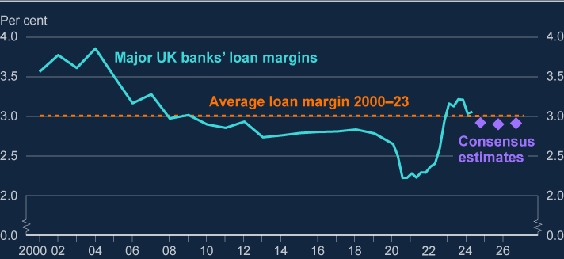

**Chart 4.1: Major UK banks’ average loan margins are down on recent peaks but expected to stabilise around their long-run average**

Average margin on major UK banks’ lending since 2000 (**a**) (**b**) (**c**)

Sources: Refinitiv Eikon from LSEG, published accounts and Bank calculations.

1. Loan margin is calculated as net interest income divided by total lending. Loan margins in this chart are calculated across all currencies. Net interest income is interest income minus interest expense.
2. Figures between 2000 and 2019 exclude Virgin Money UK, and figures before 2006 exclude Standard Chartered.
3. Consensus estimates are scaled based on analysts’ expectations of loan margins for Barclays, HSBC, Lloyds Banking Group, NatWest Group, Standard Chartered and Virgin Money UK. Purple diamonds are the forecasts for 2024, 2025 and 2026.

Reflecting strong results, UK banks’ share prices rose at the start of 2024, with the FTSE 350 bank index increasing by 17% since the start of the year. Higher valuations have been reflected in PtTB ratios, with the average UK bank PtTB ratio rising to around one, up from Covid-era lows of around 0.5. UK banks’ PtTB ratios are further discussed in Box A. Several acquisitions were also announced during this period, which would, if completed, lead to some consolidation within the UK banking sector.

##### Asset quality for major UK banks has remained strong since the December FSR.

The overall risk environment remains challenging as higher interest rates continue to put pressure on households and corporate borrowers, with refinancing at higher rates not yet complete. Since the December FSR, mortgage arrears have remained broadly flat and are expected to remain well below their historical peaks. Business insolvencies have risen slightly but remain well below their long-term average level (see Section 3). Certain global risks have continued to crystallise (see Section 2).

Some forms of lending – as well as lenders that are more concentrated in those assets – are more exposed to credit losses as borrowing costs rise or should economic conditions turn out worse than expected. This includes consumer credit, buy-to-let and commercial real estate lending, and lending to highly leveraged corporates. The global banking system has significant exposures to private equity-related activity, including via leveraged lending, and these are discussed (see Section 6).

On some measures, leveraged loan defaults globally have increased further since the December FSR, and vulnerabilities in mainland Chinese and Hong Kong property markets continue to crystallise (see Section 2). But leveraged loan defaults and property price declines in mainland China and Hong Kong remain significantly less severe than levels to which major UK banks were tested as part of the 2022/23 annual cyclical scenario bank stress test.

Major UK banks’ forward-looking indicators of asset quality have improved since the December FSR. The share of loans either for which there has been a significant increase in credit risk (International Financial Reporting Standard (IFRS) 9 ‘stage 2’ loans) or that are credit impaired (IFRS 9 ‘stage 3’ loans) are down, at 12.3% in 2024 Q1 compared with 13.4% in 2023 Q3. The decline has been driven by a fall in corporate loans in stage 2.

Reflecting the fact that overall asset quality has moved in line with banks’ expectations, provision coverage by major UK banks has been broadly unchanged since the December FSR, at around 1% of loans. This level remains only slightly above its 2019 pre-Covid value.

Indicators of small and medium-sized UK banks’ aggregate asset quality declined slightly. There is a wide range of business models among these banks, some of which are specialised in particular activities or serve particular sectors. This variety of business models means

individual banks will be presented with different challenges or opportunities as the environment evolves.

Overall, the UK banking system is resilient to the current economic outlook and has the capacity to support households and businesses even if economic and financial conditions were to be substantially worse than expected.

##### The FPC continues to monitor the implications of trends in banks’ funding and liquidity as central bank balance sheets normalise.

A number of system-wide trends in banks’ funding and liquidity were discussed in the [**December FSR (Box D)**](https://www.bankofengland.co.uk/financial-stability-report/2023/december-2023). An important factor is the normalisation of central bank balance sheets, as the extraordinary measures put in place following the GFC and Covid pandemic are unwound (see [**Bailey (2024)**](https://www.bankofengland.co.uk/speech/2024/may/andrew-bailey-lecture-london-school-of-economics-charles-goodhart)). The Bank of England, in accordance with the approach decided by the MPC, is unwinding holdings in its Asset Purchase Facility (APF), and the Term Funding Scheme with additional incentives for SMEs (TFSME) is coming to an end.

Taken together, these trends will affect sources of bank funding, and could affect their cost. Unwinding holdings in the Bank’s APF is likely, all else equal, to put downward pressure on the overall level of bank deposits in the system, though there is some uncertainty around the exact impact. Banks have several options as TFSME funding matures. They could choose to repay the funding by reducing their stock of liquid assets, or to replace it with other forms of funding by competing for deposits, through more wholesale issuance, or through use of the Bank of England’s facilities. Thus far, around a quarter of TFSME funding has been repaid in advance of its contractual maturity.

All else equal, the reduction of Bank of England reserves resulting from the normalisation of its balance sheet would put downward pressure on banks’ liquidity ratios. Aggregate Bank of England reserves have declined by around £200 billion since their peak in early 2022. The

level of reserves supplied by the Bank of England to support UK financial stability will have to balance the rise in liquidity relative to the pre-GFC period, when the level of reserves was inadequate, against a desire not to over-supply reserves and impede the incentives for robust private sector liquidity management.

Banks have a number of options and liquidity management tools available to them to maintain their liquid assets above their target levels as central bank balance sheets are normalised.

They can replace reserves with other forms of HQLA, and this is already happening: the share of government bonds in major UK banks’ HQLA has increased as the share of central bank reserves has decreased, the latter falling from 67% in February 2022 to 52% in April 2024.

During this period, LCRs have remained broadly unchanged. In addition, banks can use the Bank of England’s facilities, which supply central bank reserves in exchange for a wide range of liquid and less liquid collateral. They include the Short-Term Repo facility, which allows participants to borrow central bank reserves for a one-week period in exchange for high

quality, highly-liquid assets and the Indexed Long-Term Repo facility, which allows participants to borrow central bank reserves for a six-month period against the full range of Sterling Monetary Framework eligible collateral (including less liquid assets).

The impact of these system-wide factors on individual banks will depend on their funding structure and business models. It is important that banks incorporate them into their liquidity management and forward-planning over the coming years. The FPC will continue to monitor the implications of these trends for financial stability.

### : UK banks’ provision of credit

##### There has been a modest increase in total gross lending, and mortgage approvals have risen, in part in response to a fall in quoted mortgage rates since last summer.

Annual net lending growth remained historically weak in the year to April, at 1%. In Q1, there was a modest increase in total gross lending, which was primarily driven by a small increase in mortgage lending (Chart 4.2), though the level of mortgage lending remains subdued compared with levels seen over 2015–19.

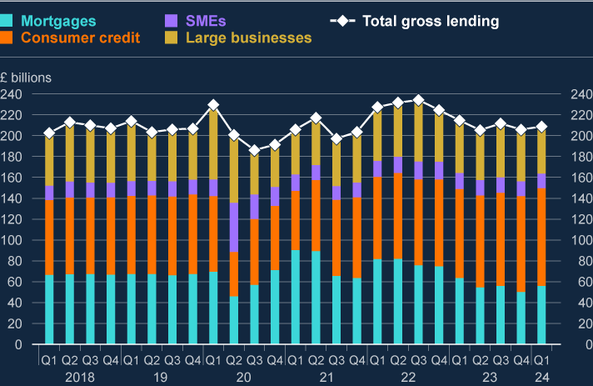

**Chart 4.2: Total lending volumes remain broadly flat**

UK monetary financial institutions’ gross lending to UK households and businesses, seasonally adjusted (**a**)

Sources: Bank of England and Bank calculations.

(a) SMEs are defined as businesses with annual debit account turnover on the main business account up to £25 million. Large businesses are those with annual debit account turnover on the main business account of over £25 million.

Mortgage approvals for house purchases rose to an 18-month high in March, in the context of lower quoted rates leading to increased demand ([**2024 Q1 Credit Conditions Survey**](https://www.bankofengland.co.uk/credit-conditions-survey/2024/2024-q1)(CCS)). Competition in the mortgage market contributed to a further tightening in mortgage spreads in Q1, and there are reports in the Q1 CCS of a slight easing in non-price terms in response to the improved macroeconomic outlook, albeit within banks’ existing risk appetites.

Overall credit conditions for corporates have remained broadly unchanged since the December FSR. Intelligence from the Bank’s Agents suggests that some large companies are seeking to borrow from banks to delay capital market issuance, in the expectation that market rates will fall further out. Lenders reported a slight increase in the availability of credit to large businesses in the Q1 CCS, but this is yet to be reflected in lending volumes data.

For small businesses, the CCS indicated an increase in credit availability for the past two quarters. Intelligence collected by the Bank’s Agents from businesses themselves, however, continues to suggest little change and that SMEs judge overall credit availability to remain quite tight. The Q1 CCS reported flat demand for credit from smaller businesses.

##### Credit conditions continue to reflect the macroeconomic outlook.

In its assessment of what has driven changes in credit conditions, the FPC considers a range of factors. These include the quantity, quality and price of credit available; indicators of the macroeconomic environment; and indicators of demand including from the CCS. The FPC also considers the resilience of the UK banking system, which remains well capitalised with headroom over regulatory requirements and buffers.

Taking these factors into consideration, the FPC judges that changes in credit conditions overall continue to reflect changes in the macroeconomic outlook.

##### The FPC has maintained the UK countercyclical capital buffer (CCyB) rate at its neutral setting of 2%.

The FPC sets the UK CCyB rate to help ensure that the UK banking system is better able to absorb shocks without an unwarranted restriction in essential services, such as the supply of credit, to the UK real economy. The FPC has decided this quarter to maintain the UK CCyB rate at its neutral setting of 2%.

Maintaining a neutral setting of the UK CCyB in the region of 2% should help to ensure that banks continue to have capacity to absorb unexpected future shocks without restricting lending in a counterproductive way.

The FPC will continue to monitor developments closely and stands ready to vary the UK CCyB rate, in either direction, in line with the evolution of economic and financial conditions, underlying vulnerabilities, and the overall risk environment. The Bank’s 2024 desk-based stress-test exercise will further inform the FPC’s assessment of the resilience of the UK banking system to downside risks (see Box B).

## Box A: UK banks’ price to tangible book ratios

This box explores recent trends in UK banks’ price to tangible book (PtTB) ratios, including in relation to banks in other jurisdictions.

##### Banks’ PtTB ratios reflect the market view of expected future shareholder returns relative to risk.

The difference between the accounting value of a firm’s assets and liabilities, adjusting for intangible assets such as goodwill, is known as the tangible book value of its equity. By comparison, the market value of the firm’s equity takes into account expectations of future returns, and the compensation required for uncertainty about those returns. A

firm’s PtTB ratio is the ratio of the market value of its equity relative to the tangible book value of that equity.

PtTB ratios reflect a number of underlying drivers, including: factors which affect the equity market as a whole, such as the perception of the macroeconomic outlook and market depth; factors specific to the banking sector, such as the regulatory and policy landscape and outlook, including with respect to the degree of competition; and factors which affect individual banks, such as the central outlook for profitability and investors’ confidence in that outlook.

In general, a PtTB ratio of one indicates that investors expect returns on tangible equity (RoTE) to be at or around the level needed to compensate them for the perceived riskiness of those returns (referred to as the ‘cost of equity’), but it is normal for the ratio to fluctuate both above and below one, for example as the market price responds to a changing outlook for earnings.

The FPC monitors PtTB ratios as one indicator of investor confidence in the ability of the banking sector to generate earnings that will allow it to support households and businesses, as well as an indicator of risk to the viability of different business models. Low PtTB ratios can affect banks’ willingness or ability to support the real economy by making it more difficult for them to raise capital. PtTB ratios can also affect decisions made by individual firms regarding their business models, the amount of profit they retain as capital, and longer-term investment decisions.

##### The average PtTB ratio of UK banks has recently risen to around one, similar to that of euro-area banks.

UK bank share prices have risen recently, reflecting higher return on equity and increasing investor confidence in its sustainability. Reflecting that, the average UK bank PtTB ratio is around one, up from Covid-era lows of around 0.5 (Chart A).

Over the past decade, trends in UK banks’ average PtTB ratio broadly match euro- area banks. However, the average PtTB ratios of both UK and euro-area banks are consistently lower than those of US banks (Chart A).

While US banks have been more profitable on average since the global financial crisis, the gap has recently closed. 2024 Q1 results show an average 14% underlying RoTE for major UK banks, which is very similar to the equivalent figure for large US banks. In addition, major UK banks’ profitability is expected by equity market analysts to remain robust in aggregate (see Section 4.1). That would suggest that factors other than RoTE are likely to be driving the cross-jurisdiction divergence in average PtTB ratios.

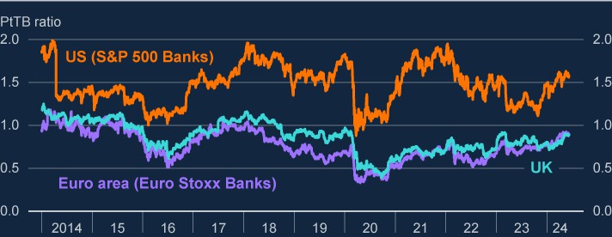

**Chart A: Major UK banks’ aggregate PtTB ratio has recently risen, and is at a similar level to that of euro-area banks but lower than US banks**

PtTB ratios for UK, euro area, and US bank indices (**a**)

Sources: Bloomberg Finance L.P. and Bank calculations.

(a) The UK series is a weighted average (by book value) of Barclays, Lloyds Banking Group, HSBC, NatWest Group and (from 2016) Standard Chartered.

##### The difference in banking sector equity valuations in the UK relative to the US is similar to that of other economic sectors.

The difference between the price-to-earnings ratio of major UK banks and US banks is similar to the difference between the price-to-earnings ratio of other sectors of the UK economy and their US counterparts (Chart B). This is consistent with market

intelligence suggesting that market-wide factors are significant drivers of UK bank PtTB ratios relative to those of US banks.

Market-wide divergence of equity valuations could reflect factors such as differences in the macroeconomic outlook – to which bank earnings are particularly sensitive – between the US and the UK, and different market depth.

Some investors also cite cross-border differences in the regulatory and policy landscape and outlook, including with respect to the degree of competition. Market intelligence suggests that UK banks’ PtTB ratios do not reflect perceptions of weak asset quality.

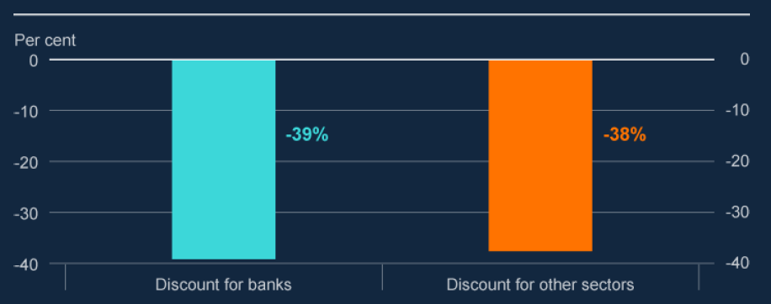

**Chart B: The one-year forward price-to-earnings discount for UK banks relative to US banks is broadly in line with that for other sectors**

The difference between one-year forward price-to-earnings for UK and US equities, for banks and other sectors (**a**)

Sources: Bloomberg Finance L.P. and Bank calculations.

(a) The analysis covers the largest five UK and largest five US banks. The discount for other sectors is for the FTSE 350 (excluding banks) relative to the US S&P 500 (excluding banks and information technology). The impact of the information technology sector on the S&P 500 has been stripped out, given its significantly larger impact on the US index than the UK.

##### Variations of individual banks’ PtTB ratios within jurisdictions broadly reflect differences in expected profitability.

Within jurisdictions, there is considerable variation in the PtTB ratios of individual banks. These valuations are broadly correlated with the expected profitability of

individual banks (Chart C). Investors cite their confidence in the sustainability of the

central outlook for earnings in the context of different business models as an important factor. Within the UK average, major UK banks’ PtTB ratios currently range from around 0.6 to around 1.1.

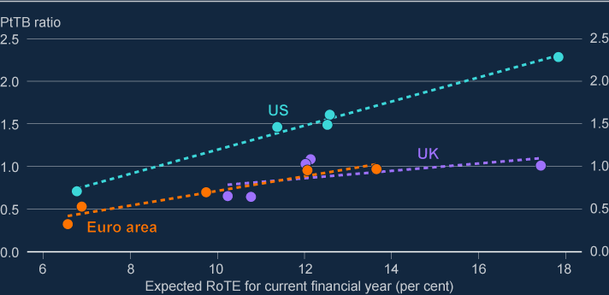

**Chart C: Differences between banks’ PtTB ratios within jurisdictions are broadly correlated with expected returns**

Expected RoTE for the current financial year and PtTB ratios for the largest UK, US and euro-area banks (**a**)

Source: Bloomberg Finance L.P., LSEG Eikon and Bank calculations.

(a) Expected RoTE is an average of equity market analyst estimates.

**The FPC will continue to monitor developments in UK banks’ market valuations, including in comparison to international peers.**

## Box B: The 2024 desk-based stress test

##### The Bank will conduct a desk-based stress test of the resilience of the UK banking system by the end of 2024.

The Bank is carrying out a desk-based stress-test exercise in 2024 to test the resilience of the UK banking system to downside risks. This will support the FPC’s and Prudential Regulation Committee’s (PRC’s) monitoring and assessment of the banking system. The exercise will not involve firm submissions of stressed projections. It will use the Bank’s own estimates of the impact of the stress scenarios on the resilience of the UK banking system.

A key benefit of a desk-based exercise is that it enables the FPC and PRC to test bank resilience to more than one adverse macroeconomic scenario. The exercise will test the resilience of the banking system, as represented by the major UK banks and building societies that account for around 75% of the sector’s lending to the UK real economy, to two hypothetical scenarios.

##### The 2024 exercise consists of two severe but plausible scenarios.

The scenarios include severe but plausible combinations of adverse shocks to the UK and global economies. The scenarios are countercyclical and linked to the FPC’s assessment of the underlying level of risks and vulnerabilities in the UK and global economies and financial markets.

**The supply shock scenario** sees a severe, negative global aggregate supply shock from an increase in geopolitical tensions and global commodity prices and supply-chain disruptions. This leads to higher-than-expected inflation across advanced economies. High inflation is assumed to lead to expectations of higher inflation in the future and global policymakers increase interest rates to bring inflation back to target. In this scenario, Bank Rate rises to 9% and stays there for a year.

**The demand shock scenario** sees a severe negative global aggregate demand shock and global recession, resulting in falling inflation. This prompts Bank Rate to fall rapidly from 5.25% to 0.1%, remaining below 0.5% for two years, to support the recovery and return inflation to target.

In both scenarios, there is a domestic and global recession, with UK GDP falling by 5%, unemployment rising to 8.5%, and house prices falling by 28%. World GDP falls by 3%. The macroeconomic scenario results in sharp moves in other asset prices.

There are assumed to be further falls in UK and global commercial real estate (CRE) prices, equity prices fall, government bond term premia rise, and corporate bond spreads widen.

The scenarios applied in the stress test are not a forecast of macroeconomic and

financial conditions in the UK or abroad and are not a set of events that are expected, or likely, to materialise. Rather, as per the scenarios used in previous exercises, they represent coherent ‘tail-risk’ scenarios designed to be severe but plausible and broad enough to assess the resilience of the UK banking system to a range of adverse shocks. Monetary policy responses in the scenarios do not represent a forecast of how policy would actually respond in such a scenario.

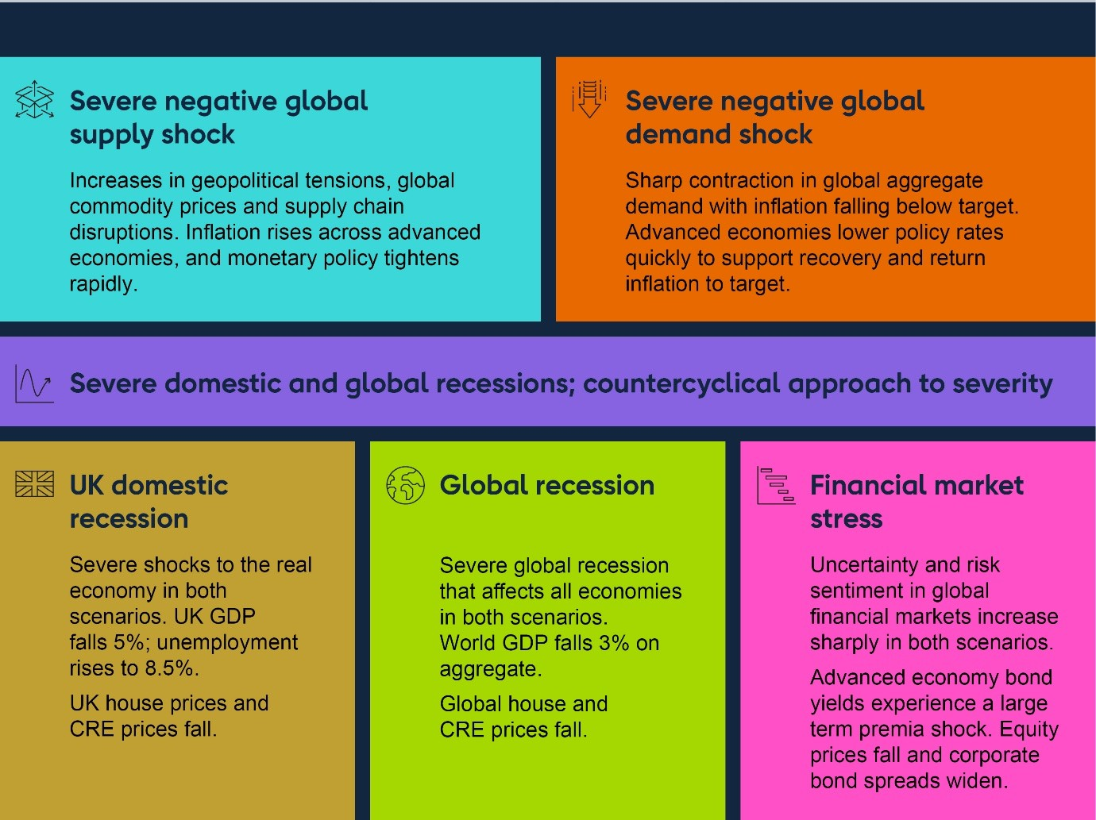

**Figure A: Summary of the scenarios for the desk-based stress test**

The Bank will publish findings from the desk-based exercise at an aggregate level by the end of 2024. It will not publish results at the level of individual banks. The scenarios for the 2024 exercise are set out in more detail in [**Stress testing the UK**](https://www.bankofengland.co.uk/stress-testing/2024/stress-testing-uk-banking-system-scenarios-2024-desk-based)[**banking system: scenarios for the 2024 desk-based stress test**](https://www.bankofengland.co.uk/stress-testing/2024/stress-testing-uk-banking-system-scenarios-2024-desk-based).

# 5: The resilience of market-based ﬁnance

### Key developments since the December 2023 FSR

Vulnerabilities in market-based finance (MBF) have contributed to a number of stress events over recent years and remain elevated. These vulnerabilities could amplify a sharp repricing in financial markets, which is a particular risk given current stretched valuations. As such, there continues to be an urgent need to increase resilience in MBF and the FPC continues strongly to support international work to achieve this.

Outflows in high-yield bond open-ended funds have been orderly, while investment- grade US dollar and euro open-ended funds have seen large inflows. The risk remains, however, that a sharp widening in credit spreads from currently compressed levels could trigger rapid outflows.

There are further signs of increased hedge fund leverage, with some funds moving into more leveraged strategies.

Vulnerabilities associated with concentrated leveraged positions and associated margining practices in over-the-counter markets, particularly in core markets (including repo markets), remain material. The FPC supports the Financial Stability Board’s (FSB’s) international work programme on leverage in non-bank financial institutions (NBFIs), and encourages authorities globally to take action to reduce the vulnerabilities through internationally co-ordinated policy reforms.

Given the significant progress made on liability-driven investment (LDI) fund resilience across domestic and international authorities over the past 18 months, the FPC has closed its LDI resilience recommendations. The FPC’s March 2023 Recommendation that The Pensions Regulator (TPR) should have the remit to take into account financial stability considerations in its work on a continuing basis remains in place.

Work to strengthen the Bank’s toolkit to intervene where severe liquidity-related dysfunction in gilt markets threatens financial stability is continuing.

The FPC welcomes the launch in June 2024 of Round 2 of the scenario phase of the system-wide exploratory scenario (SWES) exercise.

### : The FPC’s approach to assessing risks from market-based ﬁnance and building resilience

##### MBF plays a central role in the financial system. The FPC monitors and assesses risks associated with MBF and seeks to build resilience where it is needed.

MBF is the system of markets, NBFIs and infrastructure which, alongside banks, provides financial services to support the wider economy. NBFIs such as insurers, hedge funds and

private finance firms (eg private equity or private credit firms) are connected to each other and to other parts of the financial system, including banks. They have come to play an increasingly central role in the UK financial system, now accounting for around half of total

financial sector assets and more than half of the lending to UK corporates.

This growth has diversified the supply of finance for UK businesses. But it also makes it essential that MBF is resilient enough to absorb, and not amplify, financial and economic shocks. Policy measures to improve resilience can help reduce the likelihood that

vulnerabilities in MBF cause wider disruption, and can reduce the impact of such disruption if it occurs. The FPC has [**previously set out**](https://www.bankofengland.co.uk/financial-stability-in-focus/2023/october-2023)its approach to identifying and assessing risks associated with MBF, building resilience, and responding when disruption occurs.

### : Developments in vulnerabilities in market-based ﬁnance

The FPC has previously identified several vulnerabilities in the system of MBF, which remain significant. These include:

liquidity mismatch in money market funds (MMFs) and open-ended funds (OEFs); as seen in the global financial crisis (GFC) and the 2020 dash for cash;

instances of concentrated leverage in NBFIs, for example in liability-driven investment (LDI) funds (where stress crystallised in late 2022), and in hedge funds;

liquidity demands from margin calls in times of stress; as seen in the ‘dash for cash’ in March 2020; and

the insufficient capacity of markets to intermediate in stress, so-called jump-to-illiquidity risk, as also seen in the ‘dash for cash’.

These vulnerabilities can lead to forced selling, the amplification of price moves, and the impairment of core market functioning, which may affect the cost and availability of finance for UK households and corporates.

Challenges associated with a higher and more volatile interest rate environment could trigger the crystallisation of these vulnerabilities. Risk premia have been falling across a number of asset classes since the December FSR and are compressed in historical terms (see Section 1). A sharp correction in a broad range of asset prices, including equities and certain credit markets could lead to a significant increase in liquidity demand among NBFIs, as well as

significant losses for some investors. Given the known vulnerabilities and interconnections within MBF, this might lead to a broader stress in the system, which could ultimately reduce the availability or increase the cost of borrowing for UK households and businesses.

##### Liquidity mismatches can arise when assets are less liquid than liabilities, as is the case for many OEFs.

This liquidity mismatch creates a risk that investor outflows could overwhelm OEFs’ capacity to liquidate assets in an orderly manner, which may lead to forced selling and amplification of moves in asset prices.

OEFs for riskier corporate credit, such as high-yield bonds, have seen material – but orderly – net investor outflows over the past two years. For example, euro high-yield bond funds have seen outflows of around 4% of assets under management since January 2022. In line with an increase in investor risk appetite, these have stabilised or, in some cases, reversed since the December FSR (Chart 5.1). In May, there were outflows in sterling high-yield bond funds, which are small in aggregate.

Meanwhile, OEFs for euro and US dollar investment-grade bonds have seen large inflows. Investment appetite for OEFs for sterling investment-grade bonds has not picked up in the same way (Chart 5.1). A sharp widening in credit spreads from currently compressed levels, especially in the US, could trigger rapid outflows, with the large growth in IG funds increasing the scale of potential vulnerabilities in this part of the market.

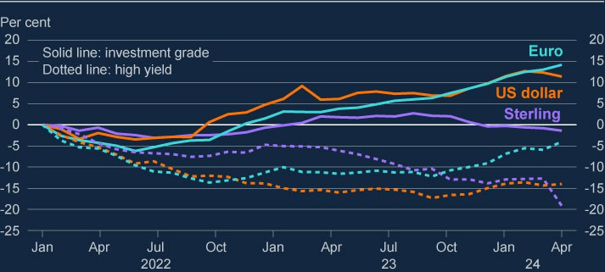

**Chart 5.1: Outflows from high-yield bond open-ended funds have been orderly, while investment grade US dollar and euro open-ended funds have seen large inflows** Cumulative flow as a percentage of assets under management (**a**)

Sources: Morningstar and Bank calculations.

(a) Data as of 31 May 2024, using Morningstar’s definitions of fund classes.

Sterling Low Volatility Net Asset Value MMF resilience decreased in 2024 Q2. Weekly liquid asset holdings were 46%, below the post-‘dash for cash’ average of 50% (between 2020 Q2 and 2024 Q1).

##### There are further signs of increased hedge fund leverage, with some funds moving into more leveraged strategies.

As outlined in the December FSR, hedge funds play a role in intermediating between different types of market participants, helping to keep cash bonds and futures markets broadly aligned through ‘cash-futures basis trades’, thus improving market liquidity and efficiency. But this intermediation can amplify stress should hedge funds be forced to rapidly unwind their positions, especially as hedge funds use significant amounts of leverage, supported by short- term borrowing in the repo market.

These behaviours are particularly evident in US Treasury markets. Hedge funds’ net short positioning in US Treasury futures has increased since 2024 Q1 but is only slightly higher than at the time of the December 2023 FSR. Basis trade activity remains driven by structural demand from asset managers for exposures to US Treasuries and an increasing preference to source this exposure via the futures market.

Data reported to the Financial Conduct Authority (FCA) show signs of increased leverage by some types of hedge funds over the past year or so. For example, for hedge funds reporting to the FCA, repo borrowing relative to hedge fund equity capital has continued to increase since 2022, and as of Q1 2024 was around its highest level since 2020, although still some way below pre-covid peaks. This recent rise in leverage appears to reflect increasing activity in fixed-income relative-value strategies, where hedge funds trade similar fixed-income instruments to benefit from small differences in pricing (eg the cash-futures basis trades described above). Such strategies are generally more leveraged than other hedge fund strategies, largely funded by borrowing through repo markets. This makes them vulnerable to tightening of conditions in repo markets. It also makes them vulnerable to other hedge funds unwinding positions when they face losses.

Private equity, which is a significant source of finance for many UK companies, is facing challenges in an environment of higher interest rates, in part because of the high degree of leverage in the sector. The FPC has identified several vulnerabilities in the sector which could amplify the impact of shocks on the availability and cost of finance to corporates (see Section 6).

### : Improving the resilience of market-based ﬁnance

Given the potential for vulnerabilities in MBF to pose risks to UK financial stability, the FPC seeks to build the resilience of MBF. The high degree of interconnectedness in MBF, including across borders, means that vulnerabilities are most effectively addressed through internationally co-ordinated reforms. The FPC continues strongly to support international work to increase the resilience of MBF. The FPC also works to reduce vulnerabilities domestically where this is effective and practical.

Some progress has been made in addressing key vulnerabilities in the system of MBF, including since the December FSR (see Table 5.A). But vulnerabilities remain and could amplify any future shocks.

##### Vulnerabilities associated with concentrated leveraged positions and margining practices in over-the-counter markets, particularly in core markets (including repo markets), remain. The FSB is working on policies to enhance the monitoring of, and to address financial stability risks stemming from, leverage in NBFI.

The FPC has previously identified non-bank leverage as a vulnerability in market-based finance. It had an amplifying effect in the Archegos default in 2021, the March 2020 ‘dash for cash’, the commodities market shock in early 2022, and the LDI episode in late 2022.

NBFI leverage vulnerabilities can cause financial stability risks through two transmission channels: (i) via systemic markets, where deleveraging flows or liquidity demands to meet collateral or margin calls could lead to fire sales which amplify shocks, and (ii) via systemic

institutions, where stress or default of a leveraged entity could propagate stress to its counterparties including banks. Macro-financial vulnerabilities such as concentration, interconnectedness and liquidity stress can further amplify these risks, causing them to become systemic.

The nexus between leverage concentration, interconnectedness, and jumps to illiquidity is challenging for authorities to monitor, due to the cross-border nature of risks, the interrelation between individual entities and core markets, and a lack of timely, risk focused data. In September 2023, the FSB published a [**report**](https://www.fsb.org/2023/09/the-financial-stability-implications-of-leverage-in-non-bank-financial-intermediation/)on the financial stability implications of leverage in NBFI, and in its subsequent work identified the following issues:

Infrequent regulatory reporting of leverage, challenges in integrating entity and activity-

level regulatory data, and a lack of appropriate risk metrics for measuring and aggregating synthetic leverage. Additionally, gaps in reporting NBFI liquidity resilience and leverage providers exposures, and the need for more consistent reporting standards across jurisdictions.

Fragmentation of data and metrics across and within jurisdictions, and legal restrictions to share entity or transaction-level data internationally.

The high degree of interconnectedness and cross-border activity associated with concentrated leveraged positions in core markets means that these risks are most effectively addressed through internationally co-ordinated reforms.

The FSB will publish a consultation report on NBFI leverage policy recommendations or policy options later in 2024. The FPC welcomes this work and the work of international and domestic regulators to develop appropriate policy responses to address the systemic risks from leverage in NBFI.

The FPC also welcomes the publication of policy proposals and best practices for margining by the [**Basel**](https://www.bis.org/bcbs/publ/d569.pdf)Committee on Banking Supervision (BCBS), [**Committee**](https://www.bis.org/bcbs/publ/d568.pdf)on Payments and Market Infrastructures (CPMI), and [**International**](https://www.bis.org/cpmi/publ/d221.pdf)Organization of Securities Commissions (IOSCO),and the FSB’s [**consultation**](https://www.fsb.org/2024/04/liquidity-preparedness-for-margin-and-collateral-calls-consultation-report/)on recommendations to enhance the liquidity preparedness of non-bank market participants for margin and collateral calls. Finalising these reforms and their subsequent domestic implementation is critical to address the vulnerabilities in NBFI and avoid regulatory arbitrage and cross-border spillovers.

The US Securities and Exchange Commission’s new [**‘T+1’ settlement cycle rules**](https://www.sec.gov/oiea/investor-alerts-and-bulletins/new-t1-settlement-cycle-what-investors-need-know-investor), which came into force on May 28, require faster settlement for all securities. This reduces counterparty credit risk in financial markets – in particular by diminishing the risk of counterparties to securities trades defaulting between the execution of a trade and its settlement – and so also reduces margin requirements.

##### Given the progress made on LDI resilience across domestic and international authorities over the past 18 months, the FPC has decided to close its November 2022 and March 2023 Recommendations relating to LDI resilience.

LDI is an investment approach used by defined-benefit (DB) pension schemes to help ensure that the value of their assets (ie their investments) moves in line with the value of their liabilities (ie the pensions they have promised to pay in the future).

Following the gilt market stress in autumn 2022, the FPC recommended in November 2022 that regulatory action be taken by TPR, in coordination with the FCA and overseas regulators, to ensure LDI funds remain resilient to a higher level of interest rates. In [**March 2023 the FPC**](https://www.bankofengland.co.uk/financial-policy-summary-and-record/2023/bank-staff-paper-ldi-minimum-resilience)[**set out**](https://www.bankofengland.co.uk/financial-policy-summary-and-record/2023/bank-staff-paper-ldi-minimum-resilience)that LDI funds should be resilient to a shock to the gilt yield curve of 250 basis points, at a minimum. This is additional to maintaining sufficient resilience to manage other risks and day-to-day movements in yields. The FPC had recommended that TPR implement this standard as the supervisory and regulatory body for workplace pension schemes.

There has been continued progress in the implementation of the resilience standard for LDI funds, which is continuing to function as intended, as described in the [**Record**](https://www.bankofengland.co.uk/financial-policy-summary-and-record/2024/march-2024)of the FPC’s 2024 Q1 Policy meeting. Furthermore, on April 29, the [**Central Bank of Ireland (CBI)**](https://www.centralbank.ie/news/article/central-bank-introduces-macroprudential-measures-irish-authorised-gbp-denominated-ldi-funds-29-april-2024)and [**Luxembourg’s Commission de Surveillance du Secteur Financier (CSSF)**](https://www.cssf.lu/en/2024/04/cssf-communication-on-macroprudential-measures-for-gbp-denominated-liability-driven-investment-funds/)published the final versions of their policy framework for sterling LDI funds. Their policy framework will take effect from 29 July 2024. The policy framework contains further information on expectations for LDI funds’ buffer composition, liquidity management, and data reporting. The FPC welcomes publication of the CBI and CSSF rules on sterling LDI funds. These rules represent the final step in the implementation of a comprehensive, cross-authority resilience framework for LDI funds, covering both DB schemes and the LDI funds in which they invest.

The median leveraged pooled LDI fund has maintained resilience of around 370 basis points since the start of the year, that is the magnitude of shock to long-term gilt-yields to which they have sufficient capital to withstand. This is well above the FPC’s 250 basis points minimum and the requirements set out in the CBI’s and CSSF’s rules (Chart 5.2). In addition, funds continue to recapitalise at far higher levels than previously, with the median trigger to recapitalise remaining much lower than prior to the LDI stress in late 2022.Continued progress has also been made on the areas for improvement in operational processes the FPC has previously identified.

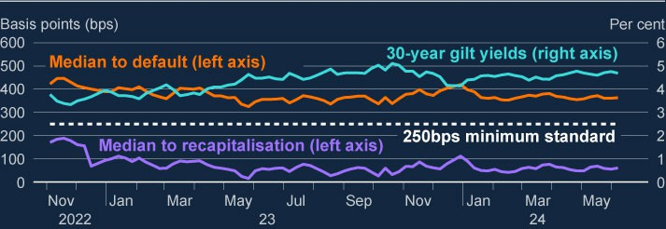

**Chart 5.2: LDI funds have maintained ample resilience**

Median basis points move in gilt yields that would trigger recapitalisation (median to recapitalisation) and cause leveraged UK pooled LDI funds to default (median to default) (**a**)

Sources: Bloomberg Finance L.P., FCA supervisory data and Bank calculations.

(a) The 250 basis point minimum resilience refers to the FPC’s Recommendation in March 2023 that that LDI funds should be resilient to stresses that account for both historical volatility in gilt yields, and the potential for their forced sales to amplify market stress and disrupt gilt market functioning. The FPC judged that these factors imply that LDI funds should be resilient to a yield shock of around 250 basis points, at a minimum, in addition to the resilience required to manage other risks and day-to-day movements in yields. Estimated resilience is based on supervisory data.

The FPC’s March 2023 Recommendation that TPR should have the remit to take into account financial stability considerations in its work on a continuing basis remains in place.

##### The FPC notes the importance of continued oversight of LDI resilience by TPR, the FCA, and international authorities.

While substantial progress has been made on operational processes in the LDI sector, it is important that these processes are maintained and tested on a regular basis. It is also important that authorities retain the ability to monitor LDI funds’ resilience in dynamic markets. The Bank is contributing to the work through its system-wide exploratory scenario (SWES), which includes pension schemes and LDI funds (see Box C).

##### The FPC welcomes continuing work to strengthen the Bank’s toolkit to intervene where a severe liquidity-related dysfunction in the gilt market threatens financial stability.

It is first and foremost the responsibility of market participants to manage the risks they face and maintain appropriate levels of resilience. The FPC recognises it is vital that domestic and international regulators continue to develop and implement policies that mitigate

vulnerabilities in the system of MBF to ensure that it can absorb and not amplify severe but plausible shocks.

But it is not feasible for non-banks to maintain a level of resilience that would insure against the most extreme system-wide liquidity stresses. In such circumstances, where reasonable levels of resilience in the market are likely to be exhausted, central bank tools can support

financial stability by providing backstop liquidity. To strengthen its toolkit, the Bank is currently developing a new lending facility to provide liquidity directly to NBFIs in times of system-wide liquidity stress in the gilt market. It is preferable, where possible, to backstop gilt market functioning by lending directly to NBFIs against high quality collateral, rather than with asset purchases, as this presents less risk to public funds and less moral hazard.

As a first step in this work, the Bank is designing a facility to address system-wide stress in the gilt market by lending to eligible pension funds, insurance companies and LDI funds against UK gilts. Given that the tool’s purpose is to address system-wide stress rather than provide individual firm liquidity insurance, it is expected to be a contingent facility, not standing. The facility would be priced to be attractive in periods of stress but expensive relative to normal market pricing. Alongside this work, the Bank is considering how access to the tool might be broadened over time to include a wider range of NBFIs that are relevant to gilt market functioning.

##### The SWES exercise will aid the FPC’s understanding of how market-based finance behaves as an interconnected system.

The FPC welcomes the launch in June 2024 of Round 2 of the scenario phase of the SWES. The Bank has shared its observations from Round 1 submissions with participating banks and NBFIs. Participants have been asked to indicate how they would expect to act in light of these Round 1 observations and some accompanying updated assumptions. The Bank will analyse responses to understand the financial stability implications of interactions between

participants’ actions (see Box C).

**Table 5.A: Overview of progress on building resilience against key vulnerabilities in MBF domestically and internationally (a)**

|  |
| --- |
| **Vulnerability Financial stability implications Policy recommendations and next steps** |
| **Maturity mismatch** arises when assets are less liquid or longer dated than liabilities. |
| **Money market** MMFs are used by UK corporates, Sterling MMFs should be able to withstand  **funds (MMFs)** investment funds, and other NBFIs severe but plausible levels of outflows, without as a way of managing cash balances. triggering runs or contagion which would create Investors hold around £230 billion in risks to financial stability.  sterling-denominated MMFs.  The FSB has agreed an [**international approach**](https://www.fsb.org/2021/10/policy-proposals-to-enhance-money-market-fund-resilience-final-report/)  Liquidity mismatch between the [**to MMFs**](https://www.fsb.org/2021/10/policy-proposals-to-enhance-money-market-fund-resilience-final-report/)(October 2021), with a suite of options redemption terms and the liquidity of to be implemented by national authorities to some of their assets makes MMFs improve MMF resilience including higher liquid vulnerable to sharp redemptions from asset requirements or liquidity management investors in stress and so risk of both tools.  runs and contagion across the sector.  This could amplify shocks, impact **In February 2024, the FSB published a**  financial stability if investors cannot [**Thematic review on money market fund**](https://www.fsb.org/wp-content/uploads/P270224.pdf)access cash, and lead to tighter [**reforms**](https://www.fsb.org/wp-content/uploads/P270224.pdf) **in national authorities, taking stock** financial conditions for the economy. **of measures adopted or planed by FSB**  **members in response to their 2021 proposal.**  **A separate follow-up work is planned by the FSB in 2026 to assess the effectiveness of those policy measures. The FSB has also recently (May 2024)** [**published a report**](https://www.fsb.org/2024/05/enhancing-the-functioning-and-resilience-of-commercial-paper-and-negotiable-certificates-of-deposit-markets/)  **assessing the functioning and vulnerabilities of commercial paper and commercial deposit markets.**  UK authorities have launched a [**consultation**](https://www.fca.org.uk/publications/consultation-papers/cp23-28-updating-regime-money-market-funds)[**paper on enhancing MMF resilience**](https://www.fca.org.uk/publications/consultation-papers/cp23-28-updating-regime-money-market-funds)[**measures (December 2023)**](https://www.fca.org.uk/publications/consultation-papers/cp23-28-updating-regime-money-market-funds), including increasing daily and weekly liquidity requirements to 15% and 50% respectively, which closed in March 2024. |

|  |
| --- |
| **Vulnerability Financial stability implications Policy recommendations and next steps** |
| **Open-ended** Globally, the assets under In 2023, the FCA [**published findings**](https://www.fca.org.uk/publications/multi-firm-reviews/liquidity-management-multi-firm-review)and [**wrote**](https://www.fca.org.uk/publication/correspondence/dear-ceo-letter-liquidity-management-multi-firm-review.pdf) **funds (OEFs)** management of OEFs primarily [**to asset manager CEOs**](https://www.fca.org.uk/publication/correspondence/dear-ceo-letter-liquidity-management-multi-firm-review.pdf)on liquidity  investing in UK equities, sterling management frameworks.  government bonds, sterling corporate  bonds, and UK property total £233 The FSB published a [**consultation paper**](https://www.fsb.org/2023/07/addressing-structural-vulnerabilities-from-liquidity-mismatch-in-open-ended-funds-revisions-to-the-fsbs-2017-policy-recommendations-consultation-report/)in July billion, £46 billion, £71 billion, and 2023 seeking to better align funds’ redemption  £10 billion respectively as of May terms with the underlying liquidity of their assets.  2024. **In December 2023, the FSB published a**  [**revised policy recommendation**](https://www.fsb.org/2023/12/revised-policy-recommendations-to-address-structural-vulnerabilities-from-liquidity-mismatch-in-open-ended-funds/#%3A~%3Atext%3DIn%202017%2C%20The%202017%20FSB%2Cin%20stressed%20market%20conditions%3B%20and) **to address**  Some OEFs offer daily redemptions **structural vulnerabilities from liquidity** while holding less liquid assets. This **mismatch in OEFs. The International** means in stress, there is an incentive **Organization of Securities Commissions**  for investors to [**redeem ahead of**](https://www.bankofengland.co.uk/report/2021/assessing-the-resilience-of-market-based-finance) **(IOSCO) has also published** [**final guidelines**](https://www.iosco.org/library/pubdocs/pdf/IOSCOPD756.pdf)[**others, or for funds to struggle to**](https://www.bankofengland.co.uk/report/2021/assessing-the-resilience-of-market-based-finance)[**on anti-dilution liquidity management tools**](https://www.iosco.org/library/pubdocs/pdf/IOSCOPD756.pdf)**.** [**meet redemption demands without**](https://www.bankofengland.co.uk/report/2021/assessing-the-resilience-of-market-based-finance) **The FSB and IOSCO will undertake a**  [**fire selling assets, leading to**](https://www.bankofengland.co.uk/report/2021/assessing-the-resilience-of-market-based-finance) **stocktake, to be completed in 2026, of the** [**contagion across markets**](https://www.bankofengland.co.uk/report/2021/assessing-the-resilience-of-market-based-finance). **measures that have been adopted and**  **planned; with a further effectiveness review by 2028 to see whether financial stability risks have been sufficiently addressed.** |
| **Leverage** involves a firm increasing its exposure to a risk factor beyond what would be possible through a direct investment of its own funds. |
| **Non-bank** Leverage creates counterparty risks The Prudential Regulation Authority (PRA) has  **leverage** and can lead to sudden spikes in published Dear CEO letters reviewing [**global**](https://www.bankofengland.co.uk/prudential-regulation/publication/2021/december/supervisory-review-global-equity-finance-businesses)demand for liquidity – either to [**equity finance businesses (2021)**](https://www.bankofengland.co.uk/prudential-regulation/publication/2021/december/supervisory-review-global-equity-finance-businesses)and [**fixed**](https://www.bankofengland.co.uk/prudential-regulation/letter/2023/fixed-income-financing-thematic-review)support the financing of leveraged [**income financing businesses (2023)**](https://www.bankofengland.co.uk/prudential-regulation/letter/2023/fixed-income-financing-thematic-review), including positions, or as de-leveraging leads recommendations for firms to review their  to forced sales, which in turn could internal risk cultures. The PRA will follow up on amplify shocks and lead to market firms’ remediation plans via ordinary supervisory dysfunction and a potential tightening channels.  in financial conditions for households  and businesses. The notional amount In September 2023, the [**FSB published**](https://www.fsb.org/2023/09/the-financial-stability-implications-of-leverage-in-non-bank-financial-intermediation/)a report of non-bank investors’ OTC on NBFI leverage. In 2024, it plans work to derivatives in 2022 has been enhance monitoring, to close data gaps and to estimated at almost US$90 trillion. consider the wider set of policy measures to  Global NBFI financial debt in 2022 contain leverage outlined in that report. **The FSB**  has been estimated at approximately **plans to issue NBFI leverage policy**  US$48 trillion, or 50% of global GDP. **recommendations or policy options in a**  **consultation report by end-2024.** |

|  |  |  |
| --- | --- | --- |
| **Vulnerability** | **Financial stability implications** | **Policy recommendations and next steps** |
| **Liability- driven**  **investment (LDI)** | LDI funds’ use of leverage makes them vulnerable to gilt yield shocks which, in the absence of recapitalisation, can trigger fire sale dynamics and amplify shocks, as seen during the September 2022 gilt market stress, which risked further market dysfunction and an excessive tightening of financing conditions to UK households and businesses. The total volume of UK defined benefit scheme liabilities hedged via LDI products is over £565 billion. | In March 2023, the FPC set out [**recommendations on steady-state minimum**](https://www.bankofengland.co.uk/financial-policy-summary-and-record/2023/bank-staff-paper-ldi-minimum-resilience)[**levels of resilience for LDI funds**](https://www.bankofengland.co.uk/financial-policy-summary-and-record/2023/bank-staff-paper-ldi-minimum-resilience)to ensure that they can absorb a severe but plausible  historical stress, over the period of time needed to recapitalise the fund, without the need for forced asset sales.  The FPC recommendations have been reflected in [**TPR**](https://www.thepensionsregulator.gov.uk/en/document-library/scheme-management-detailed-guidance/funding-and-investment-detailed-guidance/liability-driven-investment)and [**FCA**](https://www.fca.org.uk/publications/multi-firm-reviews/further-guidance-enhancing-resilience-liability-driven-investment)guidance to firms in April 2023. **In April 2024, the CBI and CSSF published their final rules on a macroprudential policy framework for sterling LDI funds.** |
|  |  | [**The resilience framework for LDI has been**](https://www.bankofengland.co.uk/financial-policy-summary-and-record/2023/october-2023)[**functioning as intended**](https://www.bankofengland.co.uk/financial-policy-summary-and-record/2023/october-2023)in a higher interest rate environment. |
|  |  | **The FPC has closed its November 2022 and March 2023 Recommendations relating to LDI resilience.** |
| **Margin calls** | Margin can increase rapidly in stress to match the increase in expected losses and risks. This ensures that counterparty risk is properly mitigated but requires counterparties to find  additional liquid assets at a time when it is more difficult for them to do so.  Increases in margin that are unpredictable or unexpectedly large can cause liquidity strains on market participants and the financial system. For example, during the March 2020 ‘dash for cash’, initial margin requirements at UK central counterparties increased by around 31% to £58 billion, with a maximum daily increase of £10 billion, and average daily variation margin calls were five times higher than in January and February 2020. | There is a need to strengthen market  participants’ preparedness to meet margin calls, as identified by a [**joint BCBS-CPMI-IOSCO**](https://www.bis.org/bcbs/publ/d537.htm)[**report on margin practices (September 2022)**](https://www.bis.org/bcbs/publ/d537.htm).  Further policy work is ongoing to improve initial and variation margining practices, to both limit the potential impacts of margin procyclicality, and better prepare market participants for jumps in margin requirements. Standard-setting bodies are developing recommendations and best practice guidance across cleared and non- cleared markets.  **In April 2024, the FSB published a**  [**consultation paper on liquidity**](https://www.fsb.org/2024/04/liquidity-preparedness-for-margin-and-collateral-calls-consultation-report/) **preparedness for margin and collateral calls.** |

1. New policy developments are in **bold**.

## Box C: The system-wide exploratory scenario

##### The Bank of England has launched the next round of its system-wide exploratory scenario exercise.

The system-wide exploratory scenario (SWES) exercise is providing the FPC with new information about the behaviours of non-bank financial institutions (NBFIs) and banks during stressed financial market conditions. It is also providing information about how those behaviours might interact to amplify shocks to UK financial markets that are core to UK financial stability. There are over 50 participants in the SWES including banks, insurers, central counterparties (CCPs), funds managed by asset managers, hedge funds, and pension funds. The Bank is working closely with the Financial Conduct Authority, The Pensions Regulator, and other domestic and international regulators as part of this exercise.

In November 2023, the Bank [**launched the scenario phase of the SWES**](https://www.bankofengland.co.uk/financial-stability/boe-system-wide-exploratory-scenario-exercise/launch-of-the-scenario-phase-of-swes). Participants were asked to consider the impact of a hypothetical 10-day scenario incorporating severe, but plausible, shocks to rates and risky asset prices. The severity of the aggregate shock in these paths was faster, wider ranging, and more persistent than observed both in the March 2020 ‘dash for cash’ and the September/October 2022 liability-driven investment (LDI) episodes (see Chart A).

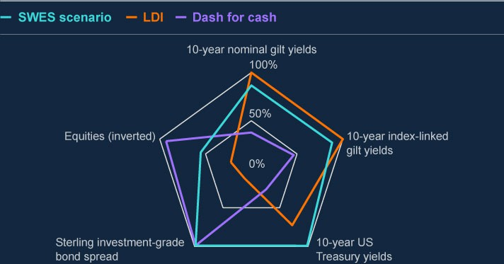

**Chart A: The SWES hypothetical scenario combines shocks to rates and risky asset prices**

Comparison of 10-day moves in selected SWES variables against the largest observed since 2001, and those observed during the dash for cash and LDI episodes (**a**) **(b**)

Sources: Bank of England, Bloomberg Finance L.P, Board of Governors of the Federal Reserve System (US), Refinitiv Eikon from London Stock Exchange Group and Bank calculations.

* 1. The gilt yield, US Treasury yield, corporate bond, and equity back data start from 1 January 2000.
  2. The increase in yields on US Treasuries is similar to that applied to all non-UK advanced economy government debt of similar maturity. This chart displays yields on 10-year US Treasury notes for indicative purposes.

The Bank has collated participants’ first round of responses to this scenario. As planned, the Bank is now running the second round of the exercise with participants to evolve the analysis based on the behaviours and interactions observed in Round 1.

The Bank has played back to participants the sectoral and system-wide observations from Round 1, which are summarised below. Participants have been asked to consider in Round 2 how their response to the SWES scenario would change in light of these observations.

##### The SWES scenario led most participating NBFIs to report significant liquidity needs in Round 1.

The impacts of the scenario on NBFI participants, and the actions they reported, varied significantly. This reflects the wide range of participating firms’ business models. In some cases, participants expected losses or, in the case of many LDI funds, that they would seek additional capital. In other cases, participants expected the impact to be

more limited. Some participants reported that they would act to increase liquidity or de- risk only for precautionary reasons. The Bank observed that many firms started the scenario with greater resilience than they had at the onset of recent market shocks.

For example, the current level of resilience of money market funds (MMFs) is well above existing minimum requirements. For some sectors, increased resilience is in part the result of recent regulatory actions, such as the LDI resilience standard recommended by the FPC.

About 80% of reported liquidity needs arising from the hypothetical scenario came from variation margin calls, just over 10% from initial margin calls, and just under 10% from redemptions (see Chart B). The Bank noted some differences between participating funds’ assumptions about redemptions arising from the SWES scenario. For example, some funds assumed no investor redemptions if they performed in line with other comparable funds, whereas others assumed investors would redeem in response to poor absolute performance. The Bank also noted some differences between CCPs’ and other participants’ expectations when estimating initial margin calls. Both sets of differences will be investigated in Round 2.

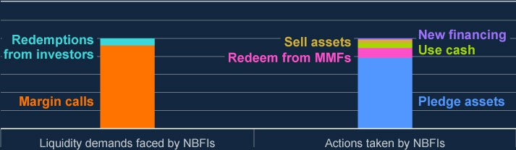

**Chart B: NBFIs expected most of their liquidity needs to arise from margin calls, and to meet most of them by pledging assets**

NBFIs’ reported liquidity demand and actions in Round 1 of the SWES (**a**)

Sources: SWES Round 1 submissions and Bank calculations.

1. The chart shows immediate liquidity demands faced by NBFIs (excluding MMFs) and immediate actions taken in response. Actions undertaken for other reasons (including to restore buffers, reduce leverage, or following investment decisions) are not shown.

##### NBFIs reported they would largely seek to use existing financial resources to meet most of their liquidity needs but this relies on assumptions that will be tested in Round 2.

While impacts and responses varied by sector, overall, NBFIs reported that they would largely meet liquidity needs by pledging assets. They would then use money market fund investments, existing cash balances, asset sales, and repo to meet the rest.

Some NBFIs also took additional precautionary actions to increase cash buffers. In Round 2, the Bank is exploring the assumptions underpinning NBFIs’ actions and how different assumptions might alter actions taken in markets.

##### Banks reported that they expected to continue making markets, and to roll clients’ existing repo, albeit on tougher terms, implying a tightening in repo market conditions.

Participating banks typically expected to roll clients’ maturing repo during the two-week horizon of the SWES scenario but with higher haircuts and at shorter tenors. Most banks reported no appetite to extend additional repo beyond existing limits, but a minority said they would be willing to do so for certain clients. Well-functioning repo markets play an important role supporting the provision of liquidity, and Round 2 will explore the implications of these tighter repo conditions for NBFIs’ activities in core markets.

##### Round 1 submissions implied significant selling pressure in the sterling corporate bond market following the shocks in the hypothetical scenario.

In response to the large shock to credit spreads incorporated in the scenario, open- ended funds, other NBFIs and some banks reported that they would, in aggregate, aim to sell a large volume of corporate bonds. Expected purchases by participants were by comparison more limited. Banks’ reported appetite to make markets in corporate bonds also appeared limited in the context of the market-wide selling pressure observed. In Round 2, the Bank will explore how a further deterioration in corporate bond markets relative to Round 1 could impact participants’ behaviour, including in other markets.

In Round 1, the Bank did not observe similar selling pressure in the gilt market. However, this depended on important assumptions about liquidity needs, about repo market functioning, and about participants’ ability to use existing financial resources or – as in the case of LDI funds – to receive timely injections of additional capital from investors. The Bank will explore these assumptions in Round 2.

##### The Bank will publish findings from the SWES before the end of 2024.

Participants will submit responses to Round 2 in 2024 Q3. The Bank expects to publish a final report on the SWES in late 2024. Published materials will not provide information on individual firms or any commercially sensitive information.

# 6: In focus – Vulnerabilities in private equity

### Summary

The private equity (PE) sector grew rapidly during the period of low interest rates and plays a significant role in financing UK businesses. The long-term nature of capital investments into PE allows and incentivises fund managers to act less cyclically, which can reduce the volatility of financing flows in macroeconomic downturns.

But the widespread use of leverage within PE firms and their portfolio companies makes them particularly exposed to tighter financing conditions.

Although the sector has been resilient so far, it is facing challenges in the higher rate environment. These manifest in refinancing risk as debt matures, and an increased drag on performance from higher financing costs.

Vulnerabilities from high leverage, opacity around valuations, variable risk management practices and strong interconnections with riskier credit markets mean the sector has the potential to generate losses for banks and institutional investors; and cause spillovers to interconnected markets such as leveraged loans and private credit – all of which could reduce investor confidence, triggering a widening in spreads from currently compressed levels, and further tightening financing conditions for businesses.

More broadly, disruptions in international PE markets could spill over to the UK, particularly from US markets given their size and importance, and because the majority of the PE investor base for UK companies is domiciled abroad, primarily in the US.

The FPC will consider the outcome of regulatory work by the PRA and FCA to address some of these issues and will continue to monitor developments in the PE sector.

Because of the interconnections between PE markets in different jurisdictions, international co-ordination will be important.

##### Having grown rapidly in the period of low interest rates, private equity plays a significant role in financing UK businesses.

PE consists of funds which use pools of capital, largely from institutional investors, to invest primarily in non-publicly traded companies. Globally, assets under management in the PE sector have increased fourfold over the past 10 years, from around US$2 trillion in 2013 to

around US$8 trillion in 2023.

PE-backed corporates account for around 5% of UK private sector revenues and around 10% of UK private sector employment, or over 2 million employees. PE has played an increasingly significant role in facilitating capital for UK corporates, helping to diversify their sources of finance. The long-term nature of capital investments into PE allows and incentivises fund managers to act less cyclically – for example by retaining assets when market valuations are impacted by a cyclical downturn. This means that PE investments can help reduce the volatility of financing flows in macroeconomic downturns. There was evidence of this during the global financial crisis (GFC) and the Covid pandemic.

However, the widespread use of leverage within PE firms and their portfolio companies makes them particularly exposed to tighter financing conditions.

##### Although the sector has been resilient so far, it is facing challenges in the higher rate environment. These manifest in refinancing risk as historic debt matures, and an

**increased drag on performance from higher financing costs.**

Private credit, in which lending is bilaterally negotiated between borrowers and lenders and typically arranged by non-bank financial institutions, and leveraged lending are important sources of finance for the PE sector, and PE-backed companies in particular. There are signs that more of these firms are struggling. Global default rates on leveraged loans have increased from around 2% in early 2022 to around 7%. This is above the long-term average, although materially below peaks reached after GFC of around 12%.

As financing costs have risen, lenders and borrowers have increasingly turned to amend-and- extend agreements – where lenders agree to push back a loan’s maturity, often in return for a higher yield and tighter financial controls – and payment in kind agreements – where borrowers with low liquidity issue new debt in order to meet interest payments. Such actions reduce near-term debt pressures on PE-backed corporates but can create future refinancing risks.

In a higher-rate environment, higher financing costs create an increased drag on the performance of indebted PE-owned companies, which makes it challenging for PE sponsors to exit their investments in their portfolios. There have been limited initial public offerings and sale activity has been weak, resulting in PE firms increasing their holding periods of portfolio companies. Pressure on PE funds to return capital to end-investors has also resulted in funds increasingly turning to unconventional approaches such as continuation vehicles, which are typically used by funds to restructure and spin off the ownership of selected sponsored companies, thereby providing an exit opportunity on investments.

There is also evidence that PE funds have increasingly resorted to taking secured borrowing against the net assets of their funds, known as net asset value (NAV) financing. The NAV financing market globally is estimated to be around US$100 billion and is expected to grow further over the coming years. This type of debt is used to monetise assets and source liquidity. However, as the providers of NAV facilities have recourse to the assets of PE funds, and these assets are leveraged themselves (‘leverage on leverage’), this type of lending can increase the risk profile for lenders in the market.

These trends are particularly pronounced in the US, where fundraising and exit activity has fallen more sharply than in the UK.

##### Vulnerabilities in the PE sector include multiple layers of leverage and strong interconnections with riskier credit markets, where underwriting practices weakened through the low rates era. In addition, valuation and risk management practices vary and are opaque.

Vulnerabilities in the PE ecosystem could amplify shocks and disrupt the stable provision of finance to the real economy.

First, the PE market has multiple financing structures, and layers of leverage, much of which are provided by banks. Layers of leverage expose lenders to risks at the portfolio company level, at the fund level, and at end-investor level. PE funds use leverage to increase returns for investors, fund deals, and manage cash flows. In the leveraged buyout space, PE- sponsored companies are typically highly leveraged corporates with floating-rate debt, and, unless hedged, are exposed to changes in interest rates. A lack of transparency to those outside the PE market makes it challenging to gauge the aggregate degree of leverage and interest rate exposure across the system. Leverage can also create liquidity demands despite the closed-end nature of funds.

Second, the PE sector is highly interconnected with the system of market-based finance (MBF) and the financial system more broadly. The PE ecosystem involves investors and lenders from different parts of the financial system, such as pension fund and insurance investors, as well as banks and private credit lenders. Globally, PE-sponsored activity is heavily associated with leveraged lending and private credit, with around 73% of leveraged loans and around 90% of private credit linked to PE-sponsored companies, according to Bank analysis.

In the UK, a large proportion of PE-backed companies’ debt is from risky credit markets (private credit, leveraged loans, and high-yield bonds). For example, over two thirds of market-based borrowing by UK PE-backed companies is from these higher-risk markets, compared to around one quarter for all firms (Chart 6.1).

Overall, credit risk in the markets used by PE-backed firms is structurally higher now, given a weakening in underwriting standards in the years following the GFC. Examples include the increasing share of leveraged loan deals with weaker covenants, a rise in the use of earning add-backs to reduce leverage multiples, and looser documentation standards. The FPC has highlighted risks from these markets previously in the [**December 2023 FSR**](https://www.bankofengland.co.uk/financial-stability-report/2023/december-2023).

Finally, valuations and risk management practices are not transparent to those outside the sector. There is also a risk of conflicts of interest. As highlighted in the International Organization of Securities Commissions’ 2023 [**report on emerging risks in private finance**](https://www.iosco.org/library/pubdocs/pdf/IOSCOPD745.pdf), conflicts may arise throughout the lifecycle of a PE fund, and at different levels of the fund structure. For example, they can occur at the fund level (eg pressure to deploy capital) or between different types of investors (eg buyers and sellers in continuation vehicles).

Increased private credit financing adds further opacity within the PE ecosystem.

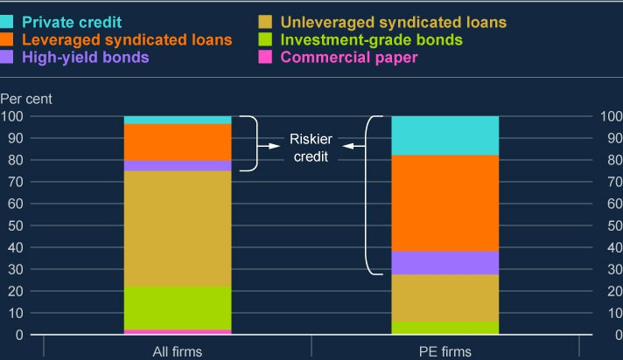

**Chart 6.1: A large proportion of UK market-based finance debt for PE-backed firms is from riskier sources**

Market-based finance debt by type (**a**) (**b**)

Sources: Refinitiv Eikon from LSEG, Preqin and Bank calculations.

1. To calculate the stock of private credit, the average maturity of private credit is assumed to be five years.
2. The data sample includes around 9,000 UK privately backed corporates with funding from private equity, private credit, and venture capital, with some year-on-year variations in the time series based on company accounts submissions. It does not capture the entire universe of UK PE-backed companies. Certain subsidiaries of consolidated groups may be included in the number for the group and separately.

##### A shock to highly indebted corporates or investor confidence could be amplified by the underlying vulnerabilities within the PE ecosystem through a number of channels, including through losses for banks…

The global banking system has significant exposure to PE activity. Such exposures could lead to credit losses for banks. In addition, opacity regarding exposures could result in a bank reducing lending to PE or other sectors by more than is warranted by macroeconomic conditions. This opacity could also have spillover effects, for example by amplifying changes in valuations, or through confidence channels.

The potential impact of losses on these exposures could in part reflect weaknesses in banks’ risk management practices. To improve risk management practices among banks lending to the sector, the PRA conducted a thematic review. This resulted in a [**Dear CRO letter**](https://www.bankofengland.co.uk/prudential-regulation/letter/2024/private-equity-related-financing-activities)

identifying gaps to be addressed in banks’ risk management frameworks relating to their PE exposures. For example, it identified a need to better employ group-wide risk data aggregation tools, stress-testing capabilities and consolidated management information reporting processes, in order to fully understand credit risk to the sector as a whole.

##### …losses for institutional investors…

For non-banks, the potential for risks to arise through losses to UK pension funds and insurers are limited given their small exposures, estimated at 5% and 1% of their total assets respectively. These exposures are unlikely to be a risk to their solvency, even if large losses occur.

Institutional investors outside of the UK are more exposed in aggregate. For example, in the US, pension funds and insurers have larger allocations to PE assets, at approximately 5%– 13% of their portfolio for pension funds and 2% of their portfolio for insurers.

This aggregate exposures data, however, masks a degree of heterogeneity and does not include exposure to other illiquid asset classes, such as private credit and real estate. Some of these illiquid markets are interconnected, and this correlation may amplify vulnerabilities in a stress.

Regulatory arbitrage opportunities in the insurance sector have incentivised some life insurers to reinsure their portfolios with offshore reinsurers. PE-connected offshore reinsurers – such as reinsurance companies, where PE companies have full or partial ownership, or a strategic partnership – often invest more in illiquid assets, potentially increasing risks. For example,

PE-connected Bermudan reinsurers allocate about 20% of their investments into illiquid assets (including PE), compared to the median for global insurers, which is around 6%.

##### …and through interconnected and highly correlated markets, such as leveraged loans, private credit, and high-yield bonds…

Shocks to indebted PE-backed corporates could spill over to interconnected and highly correlated markets such as leveraged loans, private credit, and high-yield bonds. End- investors across these markets tend to be similar, with global pension funds and insurers having a large presence. Performance in the private credit and leverage lending markets is also likely to be correlated, given that firms across these markets are likely to be highly levered. This means that within these risky credit markets, losses for investors in stress may also be highly correlated.

That said, structural features of PE markets help mitigate fire-sale risks in the underlying assets, limiting potential spillovers. PE funds are predominantly buy-and-hold closed-ended structures, with investors committing capital for long periods. Although it has grown over recent years, the secondary market for either limited partner shareholding interests or portfolio assets remains small relative to the size of the overall PE market.

##### …all of which could reduce investor confidence, triggering a widening in spreads from currently compressed levels, and further tightening financing conditions for businesses.

PE-backed companies account for around 15% of UK corporate debt in aggregate. They operate in a variety of sectors, with high concentration in finance, insurance, professional services, and information and communications. The high degree of sectoral concentration represents an additional vulnerability, which could amplify the impact of shocks in individual sectors. If a sector with a high concentration of PE-backed companies is undergoing a stress, it may be more likely to impact the PE sector more broadly.

PE backs a sizeable portion of highly leveraged vulnerable firms. Bank analysis suggests that since 2017, the share of liability-weighted PE-backed companies at higher risk of default has been larger than that of UK corporates in aggregate. But this share has been falling from its Covid peak, reflecting the recent strength in UK nominal corporate earnings (see Section 3 for more details on methodology).

The share of vulnerable PE-backed companies (as a proportion of all PE-backed firms) is similar to that of leveraged loan issuers, but higher than that of high-yield bond issuers (Chart 6.2). Some of these businesses may need to reduce their indebtedness, potentially through

new equity, in response to the higher interest rate environment.

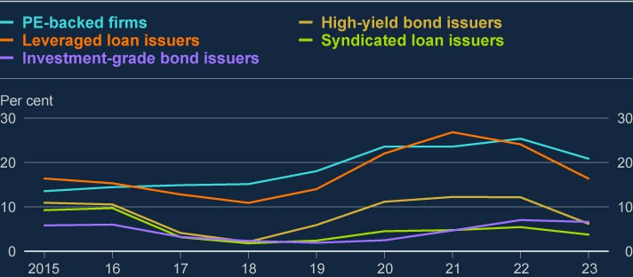

**Chart 6.2: The share of PE-backed firms at higher risk of default is similar to the share of leveraged loan issuers that are vulnerable but higher than proportion of vulnerable high-yield bond issuers**

Percentage of firms crossing interest coverage ratio, return on assets, and liquidity thresholds (liabilities weighted) (**a**) (**b**)

Sources: Refinitiv Eikon from LSEG, Preqin, Moody’s Bureau van Dijk and Bank calculations.

1. These lines represent the liability weighted share of UK corporates that simultaneously breach the three thresholds associated with the highest likelihood of firm failure: whether a company’s interest coverage ratio, calculated by dividing its earnings before interest and tax by its interest expense, is below 2.5; whether its liquidity ratios (current ratio, quick ratio, and cash ratio) are below 1.1; and whether its return on assets is negative.
2. The data sample includes around 9,000 UK privately backed corporates with funding from private equity, private credit, and venture capital, with some year-on-year variations in the time series based on company accounts submissions. It does not capture the entire universe of UK PE-backed companies. Certain subsidiaries of consolidated groups may be included in the number for the group and separately.

While the share of PE-backed firms’ debt maturing in the next five years is just under 10% of all MBF debt, it accounts for around a 25% share of all the debt maturing in risky credit markets (Chart 6.3). This means that PE-backed firms may be disproportionately exposed to refinancing risk in these riskier markets over the coming years. That could create risks through the borrower resilience channel, for example, if those corporates have to cut back sharply on investment or employment.

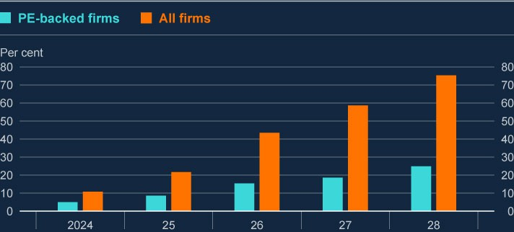

**Chart 6.3: Almost a quarter of debt in riskier MBF markets maturing over the next five years is related to PE activity**

Proportion of risky debt (leveraged loans, high-yield bonds, and private credit) maturing in PE- backed firms versus all firms, as a percentage of risky MBF debt (**a**) (**b**)

Sources: Refinitiv Eikon from LSEG, Preqin and Bank calculations.

1. The average maturity of private credit is assumed to be five years.
2. The data sample includes around 9,000 UK privately backed corporates with funding from private equity, private credit, and venture capital, with some year-on-year variations in the time series based on company accounts submissions. It does not capture the entire universe of UK PE-backed companies. Certain subsidiaries of consolidated groups may be included in the number for the group and separately.

UK based PE-backed corporates are also susceptible to shocks from outside the UK. Bank staff estimates suggest that the majority of the capital raised for UK PE-sponsored companies is from global investors, primarily in the US. Given the high level of exposure to global markets, particularly to the US, shocks to investor confidence or disruptions to US PE could lead to a contraction in funding for UK corporates.

##### The extent of transparency around asset valuations, overall levels of leverage, and the complexity and interconnectedness of the sector makes assessing the financial stability risks challenging.

It is therefore important for those in the PE sector and their counterparties to manage their risks carefully. Improved transparency over valuation practices and overall levels of leverage would help reduce the vulnerabilities in the sector.

##### The FPC welcomes regulatory work to address some of the key vulnerabilities associated with the PE sector.

As the sector grows and adapts to the challenges it faces, it is important that vulnerabilities are mitigated to ensure the sector can continue to provide finance to UK businesses sustainably, even in substantially worse economic and financial conditions.

Given the level of transparency of valuation practices in the sector, the FCA is currently

[**reviewing private asset valuation practices**](https://www.fca.org.uk/publication/correspondence/portfolio-letter-asset-management-alternatives-supervisory-strategy-interim-update.pdf), focusing on the personal accountabilities for valuation practices in firms, the governance of valuation committees, the information reported to boards about valuations, and the oversight by relevant boards of those practices. In addition, the PRA's [**Dear CRO letter**](https://www.bankofengland.co.uk/prudential-regulation/letter/2024/private-equity-related-financing-activities)(as described above), has identified gaps in banks’ risk management practices relating to their PE exposures.

The FPC will consider the outcome of this regulatory work. As this work continues,

international co-ordination will also be important because of the strong interconnections between PE markets in different jurisdictions.

# Annex: Macroprudential policy decisions

This annex lists any FPC Recommendations and Directions from previous periods that have been implemented or withdrawn since the [**December 2023 Report**](https://www.bankofengland.co.uk/financial-stability-report/2023/december-2023), as well as Recommendations and Directions that are currently outstanding. It also includes those FPC policy decisions that have been implemented by rule changes and are therefore still in force.

Each Recommendation or Direction has been given an identifier to ensure consistent referencing over time. For example, the identifier 17/Q2/1 refers to the first Recommendation made at the 2017 Q2 Committee meeting.

### FPC Recommendations implemented since the 13 March 2024 Policy meeting

On 23 March 2023, the FPC made the Recommendation (23/Q1/1) that:

The severe but plausible stresses to which liability-driven investment (LDI) funds should be resilient should account for historic volatility in gilt yields, and the potential for forced sales to amplify market stress and disrupt gilt market functioning. If LDI funds were not resilient to such a shock, their defensive actions could cause financial instability, tightening credit conditions for UK households and businesses. The FPC judged that these factors meant that the size of the yield shock to which LDI funds should be resilient should be, at a minimum, around 250 basis points.

Liquid assets held to ensure resilience in the event of such a shock should be unencumbered and immediately available. Fund managers should have scope to consider additional assets, which investors had authorised them to use to meet collateral demands. Managers should apply appropriate prudence in doing this, for example by applying suitable haircuts.

This minimum level of resilience should be maintained in normal times but could be drawn down on in stress. Minimum resilience around this level would ensure that funds could absorb a severe but plausible historical stress and still have a remaining level of headroom necessary to operate during a period of recapitalisation. This approach was consistent with the regulatory approaches in place for some systemically important financial institutions, where their standards were designed to allow institutions to continue operating after withstanding a severe stress.

Funds should take into account the nature of their exposures, including duration, leverage, and concentration of holdings, and the liquidity, duration, and convexity of collateral, in modelling their resilience to yield moves.

Pension schemes using leveraged LDI should be expected to be able to deliver collateral to their LDI vehicles within five days. Funds and schemes unable to implement these

operational standards should be required to be resilient to a larger shock, calibrated to their own operational timelines.

LDI funds should maintain additional resilience over and above the minimum to manage day-to-day volatility in yields and account for other risks they might face, including

operational risks, in order to be able to maintain the minimum level of resilience in normal times. The amount of additional liquidity held should be calibrated by funds according to their own assessments of their exposures and operational capabilities and other regulatory requirements, as well as interest rate trends and levels of market volatility. While this

additional liquidity was expected to vary between funds, when combined with the minimum resilience to yield shocks, overall resilience levels should be broadly consistent with those currently prevailing in current market conditions (ie 300–400 basis points). Liquid asset holdings might be safely reduced over time if fund managers were able to demonstrate increased resilience through operational improvements.

On 23 March 2023, the FPC made the Recommendation (23/Q1/2) that:

The Pensions Regulator (TPR) takes action as soon as possible to mitigate financial stability risks by specifying the minimum levels of resilience for the LDI funds and LDI mandates in which pension scheme trustees may invest. To ensure that they were able in practice to do this, it was important that trustees had a simple mechanism for monitoring, and LDI funds disclosing, levels of resilience in dynamic markets.

TPR should have the ability to employ effective monitoring tools, and to enforce as appropriate in cases of non-compliance with this resilience level. The FPC asked TPR to report back on how it intended to implement the Recommendation.

On 28 November 2022, the FPC recommended (22/Q4/1) that regulatory action be taken by TPR, in co-ordination with the Financial Conduct Authority (FCA) and overseas regulators, to ensure LDI funds remain resilient to the higher level of interest rates that they can now withstand and defined benefit pension scheme trustees and advisers ensure these levels were met in their LDI arrangements.

### Outstanding FPC Recommendations and Directions (as at the date of the FPC’s meeting on 11 June 2024)

On 23 March 2023, the FPC made the recommendation (23/Q1/2) that:

 TPR should have the remit to take into account financial stability considerations on a continuing basis. This might be achieved, for example, by including a requirement to have regard to financial stability in its objectives, which should be given equal weight alongside other factors to which TPR is required to have regard. The FPC noted that in order to achieve this, TPR would need appropriate capacity and capability.

### Other FPC policy decisions which remain in place

The following text sets out previous FPC decisions, which remain in force, on the setting of its policy tools. The calibration of these tools is kept under review.

#### Countercyclical capital buffer rate

The FPC agreed to maintain the UK CCyB rate at 2% on 11 June 2024, unchanged from its 13 March 2024 Policy meeting. This rate is reviewed on a quarterly basis. The UK has also reciprocated a number of foreign CCyB rate decisions – for more details see [**The**](https://www.bankofengland.co.uk/financial-stability/the-countercyclical-capital-buffer)[**countercyclical capital buffer**](https://www.bankofengland.co.uk/financial-stability/the-countercyclical-capital-buffer). Under Prudential Regulation Authority (PRA) rules, foreign CCyB rates applying from 2016 onwards will be automatically reciprocated up to 2.5%.

#### Mortgage loan to income ratios

In June 2014, the FPC made the following Recommendation (14/Q2/2): The PRA and the FCA should ensure that mortgage lenders do not extend more than 15% of their total number of new residential mortgages at loan to income ratios at or greater than 4.5. This Recommendation applies to all lenders which extend residential mortgage lending in excess of £100 million per annum. The Recommendation should be implemented as soon as is practicable.

The PRA and the FCA have published their approaches to implementing this Recommendation: the PRA has issued a [**policy statement**](https://www.bankofengland.co.uk/prudential-regulation/publication/2014/implementing-the-fpcs-recommendation-on-loan-to-income-ratios-in-mortgage-lending), including rules, and the FCA has issued [**general guidance**](https://www.fca.org.uk/publications/finalised-guidance/fg17-2-fpc-recommendation-loan-income-ratios-mortgage-lending).

#### Leverage ratio

In September 2021, the FPC finalised its review of the UK leverage ratio framework, and issued a Direction and Recommendation to implement the outcome of the review as set out in its [**October 2021 Record**](https://www.bankofengland.co.uk/financial-policy-summary-and-record/2021/october-2021).

In line with its statutory obligations, the FPC completed its annual review of its Direction to PRA. The FPC revoked its existing Direction to the PRA in relation to the leverage ratio regime, and issued a new Direction on the same terms as in September 2021 with the addition of discretion for the PRA to set additional conditions to the central bank claims exclusion.

The full text of the FPC’s new Direction to the PRA on the leverage ratio is set out in the Annex of the [**October 2022 Record**](https://www.bankofengland.co.uk/financial-policy-summary-and-record/2022/october-2022)(see Annex), together with the original Recommendation (now implemented).

The PRA has [**published its approach**](https://www.bankofengland.co.uk/prudential-regulation/publication/2021/june/changes-to-the-uk-leverage-ratio-framework)to implementing this Direction and Recommendation.

### Other FPC activities since the December 2023 Report

Other FPC activities since the December 2023 Report not included elsewhere in this Report are set out in the [**Financial Policy Summary and Record – March 2024**](https://www.bankofengland.co.uk/financial-policy-summary-and-record/2024/march-2024), and [**Financial**](https://www.bankofengland.co.uk/financial-policy-summary-and-record/2024/june-2024)[**Policy Summary and Record – June 2024**](https://www.bankofengland.co.uk/financial-policy-summary-and-record/2024/june-2024). These include:

Reiterating the growing importance of operational resilience for maintaining UK financial stability.

Developing its approach to assessing financial stability risks from potential operational incidents, which was published in the [**Financial Stability in Focus**](https://www.bankofengland.co.uk/financial-stability-in-focus/2024/march-2024)on its approach to operational resilience.

Expecting that relevant firms[5] and financial market infrastructures, eg those that were required to take account of risks to UK financial stability under the Bank, PRA and FCA operational resilience policies, should consider the vital services which were important to financial stability when they identified their important business services.

Considering the details of the next exploratory cyber stress test, which was due to start in Spring 2024 with the findings expected to be published in the first half of 2025.

Welcoming the FCA consultation paper on [**Improving transparency for bond and**](https://www.fca.org.uk/publications/consultation-papers/cp23-32-improving-transparency-bond-and-derivatives-markets)[**derivatives markets**](https://www.fca.org.uk/publications/consultation-papers/cp23-32-improving-transparency-bond-and-derivatives-markets)that was published on 20 December 2023, containing proposals to revise the transparency framework through changes to scope and calibration as well as through improved information content.

Judging that, in addition to advancing the FCA’s objectives to enhance market integrity and promote effective competition, an appropriately calibrated transparency regime would support UK financial stability.

Welcoming the FCA’s focus on proportionate calibration which sought to support continued liquidity provision by dealers.

Welcoming the fact that the final synthetic GBP Libor setting would cease on 28 March and noted that all remaining synthetic Libor settings had planned end dates in 2024; and encouraging participants to maintain momentum on transition efforts to minimise remaining exposures ahead of these dates.

Welcoming the further reduction in the stock of legacy USD Libor exposures, and consequently judging that the financial stability risk in the UK associated with USD Libor had effectively been mitigated.

Re-iterating its view that rates based on the secured overnight financing rate (SOFR) provided more robust alternatives than USD credit sensitive rates, and that these latter rates had the potential to reintroduce many of the financial stability risks associated with Libor.

Re-iterating its caution on the use of term SOFR, outside of the specific use cases recommended by industry working groups, to ensure markets transition to the most robust benchmarks.

Agreeing to publish an update on its approach to evaluate how climate change could impact UK financial stability in the June 2024 FSR (this has subsequently been postponed).

Welcoming HM Treasury's consultation on Enhancing the Special Resolution Regime, relating to a new mechanism to support small bank resolution, which closed on 7 March.